


Works Approval Application Assessment Report
  - ENVIRONMENT PROTECTION ACT 1970
WORKS APPROVAL ASSESSMENT REPORT

ENVIRONMENT PROTECTION ACT 1970

Application No. | 1003002
Applicant Name | Energy Brix Australia Corporation Pty Ltd
Address of Premises | 412 Commercial Road, Morwell, Victoria, 3840
Proposal | Establishment of an asbestos only landfill to take waste from the demolition of the old Morwell Power Station and Briquette factory
Scheduled Category | A05 Landfills, A01 PIW management

Contents

1. Background information 4

1.1 History of the site and the proposal 4

1.2 Public comment and referral process 9

1.3 Land use planning and zoning and referral to Latrobe City Council 9

1.4 Sustainability Victoria submission 10
1.5 Gippsland Waste and Resource Recovery Group submission 10

1.6 Department of Health and Human Services 11
1.7 WorkSafe Victoria 11

1.8 Public Comment 13

1.9 Track record 13
1.10 Timeline of the works approval application assessment 14

2. Policy Framework and Assessment 15
2.1 Policy framework 15
2.2 Summary of assessment: 16
2.2.1 Considerations under s. 50C of the EPAct 16
2.2.2 The level of compliance with clause 13(3) of the WMP 16
2.2.3 The level of compliance with Clause 16(2) of the WMP 17
2.2.4 Compliance with “Getting Full Value” Policy 17
2.2.5 Buffer requirements 18
2.3 Detailed designs for the landfill construction 18
2.3.1 Base and side wall liner: 19
2.3.2 Landfill cap: 19
2.3.3 Leachate collection and management 19
2.3.3.1 Variation to Landfill BPEM requirements for the leachate collection system 20
2.3.3.2 Questions asked in the second S22 notice 20
2.3.3.3 Applicant response to second S22 notice and ASD assessment 21
2.3.4.4 Conclusion 22
2.3.4 Stormwater management 22
2.3.5 Establishment and licensing of the landfill 23
2.3.6 Removal and handling of waste 23
2.3.7 Waste transport 23
2.3.8 Rehabilitation & aftercare management 23
2.4 Landfill gas management 24
2.5 Odour and dust management 24
2.5.1 Odour emissions 24
2.5.2 Dust emissions 24
2.5.3 Asbestos fibre emissions 24
2.6 Greenhouse gas emissions 25
2.7 Monitoring 25
2.8 Financial Assurance 25

3. Recommendation 26

4. Works Approval Conditions 26

LIST OF FIGURES

Figure 1: Regional location plan of the Morwell Power Station at 412 Commercial Road Morwell, Victoria. 4
Figure 2: General overview of the EBAC site 5
Figure 3: Location plan showing the boundary of the site and the proposed locations of the primary and secondary landfill cells 6
Figure 4: Location plan for the Morwell Power Station showing planning zones 7
Figure 5: Site Layout plan 8
Figure 6: Shed proposed to be used for secure storage of asbestos prior to placement in
the landfill 13

ASSESSMENT

1. Background information

1.1 History of the site and the proposal
The Morwell Power Station, built by the former State Electricity Commission in 1949, has operated at the site at 412 Commercial Road Morwell (Figure 1) since 1956. The power station and associated briquette factory was a cogeneration facility with steam from the power plant being used for the drying of coal in the briquette manufacturing process. At its peak, it could produce up to 180 MW of electricity and 1 million tonnes of briquettes for the Victorian solid fuel market. The briquette factory was taken off-line in August 2014 and the power station was taken-off line in September 2014. Briquettes continued to be supplied to the Hazelwood Power Station until early 2017.

In November 2015, HRL Ltd and its subsidiaries were placed in voluntary administration by its directors. This resulted in EBAC, a subsidiary, also being placed into administration. After an unsuccessful attempt to find a buyer for the site it was decided to undertake remediation of the site to enhance the site value and estimated return to EBAC creditors. Rehabilitation of the site requires demolition of the power station and possibly also the briquette factory. The demolition is expected to generate approximately 10,000 m³ of friable (Class A) and non-friable/bonded (Class B) asbestos containing material (ACM). This could include lagging, sheeting, refractories and asbestos gasket contaminated steel. The bulk of the ACM is expected to be asbestos cement sheeting. To safely dispose of the ACM generated from the demolition, EBAC are proposing to construct an asbestos landfill at a suitable location on the site. The proposed landfill will accept ACM generated from the site only and will not accept material from off site. EBAC are seeking approval for a landfill with a total airspace of 15,000 m³. This will be achieved by constructing two below ground cells. The primary cell of 10,000 m³ will be constructed first and the secondary cell of 5,000 m³ will only be constructed if the quantity of ACM generated is greater than the expected 10,000 m³. The maximum operating life of the landfill is expected to be two years. Detailed design for landfill construction is described in 2.3.
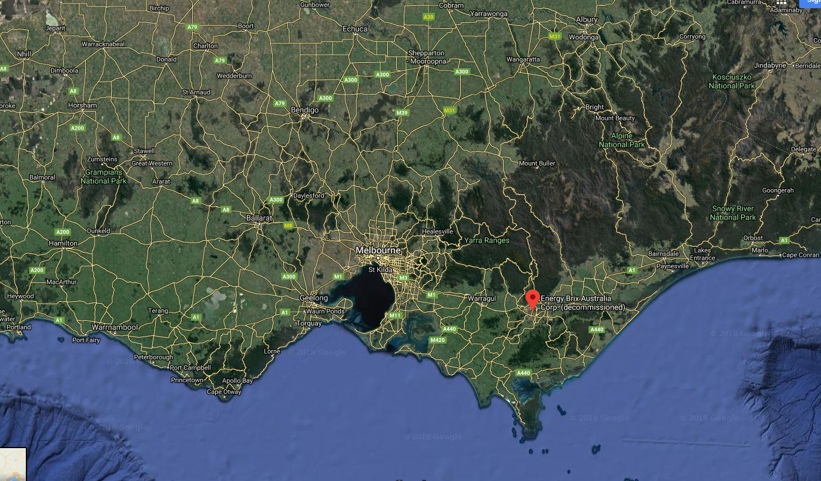

Figure 1: Regional location plan of the Morwell Power Station at 412 Commercial Road, Morwell, Victoria.

The site for the proposed landfill is shown in Figures 2 to 5 below.

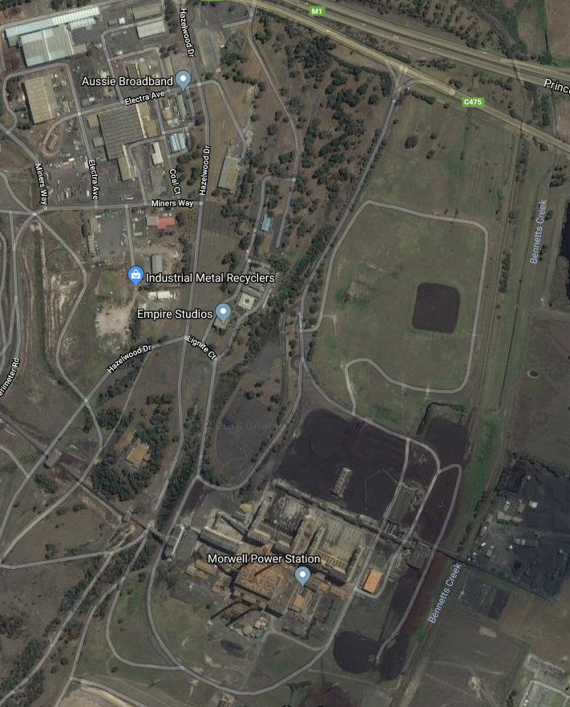

Figure 2: General overview of the EBAC site
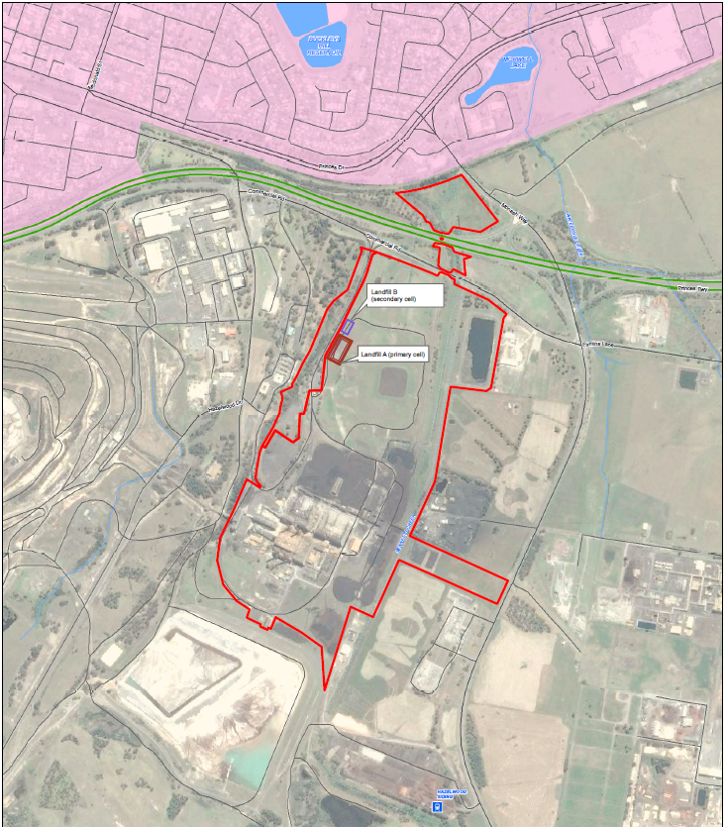
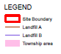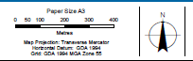

Figure 3: Location plan showing the boundary of the site and the proposed locations of the primary and secondary landfill cells
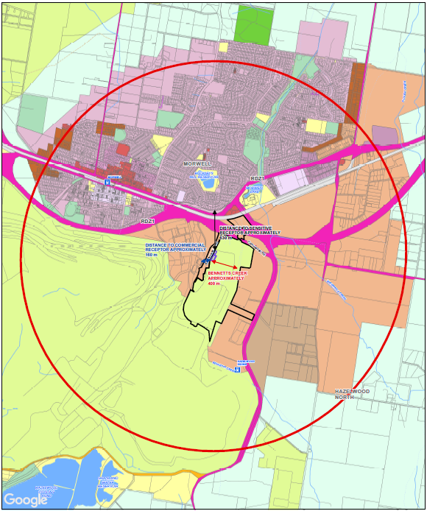
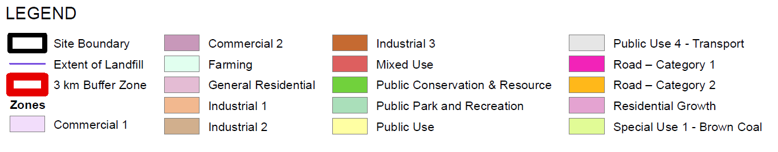

Figure 4: Location plan for the Morwell Power Station showing planning zones

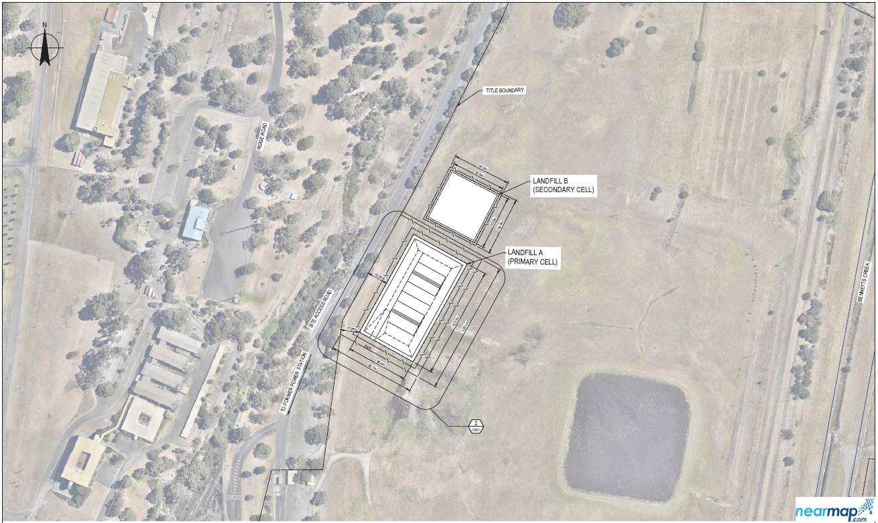

Figure 5: Site Layout plan

1.2 Public comment and referral process
The application was advertised for public comment on 14 February 2018 in the Herald Sun and the Latrobe Valley Express. EPA also put up a featured web page on the application with links to the application documents.
The application was referred to the following authorities for comment: Latrobe City Council (LCC), Sustainability Victoria (SV), Gippsland Waste and Resource Recovery Group (GWRRG), Worksafe Victoria and Heritage Victoria. EPA’s Public Health Unit was also asked to comment on the application.
A public information session was conducted by EBAC at the Morwell Bowling Club on 29 November 2017. The meeting was attended by about 70 people including EPA officers from DAU and the Gippsland Regional Office. All attendees at the meeting who provided email addresses were notified by email and invited to submit comments on the application.
All the statutory authorities responded to the referral notices and one submission was received from the public or other interested stakeholders. Heritage Victoria did not comment on the application or raise any issues for EPA to consider in its assessment.

1.3 Land use planning and zoning and referral to Latrobe City Council

The site is zoned Special Use Zone 1 (Brown Coal) under the Latrobe City Council Planning Scheme and is subject to Environmental Significance Overlay Schedule 1 (ESO1).

The site is surrounded by Industrial Use Zone 1 to the north-west, north and east of the site, Public Use Zone (PUZ6) and Farming Zone (FZ1). The Special Use Zone 1 that incorporates the site extends to the west and south and incorporates the Morwell open cut.

The Planning Zones are shown on Figure 4 above

Latrobe City Council (Council) is the appropriate planning authority and the following questions were referred to the council.

- Are the proposed works allowed by the planning scheme, with or without conditions?
- Is a permit required under the Planning and Environment Act 1987 for the proposed works?
- Has a permit has been issued under the Planning and Environment Act 1987 for the proposed works? If a permit has been issued please provide a copy to EPA.
- Are you considering an application for a permit under the Planning and Environment Act 1987 for the proposed works? or
- Are the proposed works prohibited by the Planning Scheme?

The council responded as follows: (Full response in Appendix 1)

(I) The proposed works are permitted by the Latrobe Planning Scheme subject to a planning permit.
(II) A planning permit is required by the Latrobe Planning Scheme for the proposed works.
(III) A planning permit has not been issued under the Planning and Environment Act 1987 for the proposal.
(IV) Council has received Application for Planning Permit 2017/242 under the Planning and Environment Act 1987 for the use and development of land for refuse disposal and alteration of access to a Road Zone Category 1 for the site. Council is currently considering this application.
(V) The proposal is not prohibited by the Planning Scheme.

Council is currently assessing Planning Permit Application 2017/242 in relation to this matter. It is noted that, without prejudicing Council’s decision, Council has no objection to issuing of the works approval provided that all works and development associated with the landfill is designed and implemented to the best possible standards to manage the environmental risks associated with the proposal.

It is also noted that there is considerable community concern regarding the possibility of airborne asbestos particles escaping from the site during demolition and disposal process. This is highlighted by the close proximity of the subject site to the Morwell residential area. Council will be ensuring that should a planning permit be issued for the proposed works that this issue is adequately dealt with through planning permit conditions. Council also requests that this issue be given due consideration by the EPA when assessing the Application for Works Approval.

1.4 Sustainability Victoria submission
EPA provided Sustainability Victoria (SV) with a copy of the works approval application pursuant to section 19B(3)(a)(i) of the Environment Protection Act 1970 (EP Act). This provision requires the EPA to refer a copy of the application to a protection agency which the EPA considers may be directly affected by the application.

SV is a protection agency within the meaning of section 4 of the EP Act because it has powers or duties under the Sustainability Victoria Act 2005 with respect to the environment in Victoria. In particular, SV’s objective under this legislation is to facilitate and promote environmental sustainability in the use of resources and it has been given powers to achieve this objective. The EPA considered that SV may be directly affected by the application because of Sustainability Victoria’s gazetted publication, ‘State-Wide Waste and Resource Recovery Infrastructure Plan (SWRRIP) which was gazetted on 11 June 2015. The SWRRIP is described as providing ‘Victoria with the long-term vision and roadmap to guide future planning for waste and resource recovery infrastructure to achieve an integrated system that [among other matters]: effectively manages the expected mix and volumes of waste [and] reflects the principles of environmental justice to ensure that impacts on the environment and public health are not disproportionately felt across communities.’

Sustainability Victoria (SV) made a submission to the EPA by letter dated 9 March 2018 (Appendix 2).

Submission summary

Sustainability Victoria was supportive of the proposal, in their submission they:

- Recognised that there was unlikely to be a viable re-use due to the high-risk nature of asbestos.
- That the proposal is broadly in-line with the intentions of the State-Wide Waste and Resource Recovery Infrastructure Plan (SWRRIP).
- Encouraged the recovery of any materials that are viable to be recovered (e.g. timber and concrete).
- Recommended that comments should be sought from the Gippsland Waste and Resource Recovery Group.
1.5 Gippsland Waste and Resource Recovery Group submission
The Gippsland Waste and Resource Recovery Group (GWRRG) were strongly supportive of the proposal, in their letter dated 21 March 2018 (Appendix 3) they made the following points:
- Confirmed that there was no requirement for this landfill to be incorporated into the current landfill schedule included in the Gippsland Waste and Resource Recovery Implementation Plan (Gazetted in June 2017).
- Identified that there is a shortfall of landfill capacity for this type of waste in Gippsland.
- They are satisfied that the establishment of an on-site facility specifically for the disposal of asbestos removed during these works is appropriate.
- That it serves to mitigate risks associated with increased handling of the waste asbestos and potential transport issues enroute to licensed disposal locations elsewhere in Victoria.

1.6 Department of Health and Human Services
The application was referred to EPA’s Environmental Public Health Unit (EPHU) and was not referred on to the department of Health and Human Services (DHHS). The EPHU had no concerns or objections to the application (full response in Appendix 4). EPHU did not object to this proposal on public health grounds provided that DAU are satisfied that the proponent meets relevant policies, guidelines and SEPPs, including Best Practice Environment Management Guidelines (BPEM) for this type of landfill. After care management and monitoring must be adhered to as described in the application. They also recommended monitoring of air quality for asbestos fibres during the works period.
1.7 WorkSafe Victoria
WorkSafe Victoria provided the following responses (see Appendix 5 for full responses):
Asbestos removal and packaging procedures are strictly controlled in Victoria via codes of practise and safety regulations. These include Health and Safety Regulations 2017 and follow the guidelines set out in the Worksafe Australia Asbestos Code of Practice Asbestos and EPA Publication IWRG611.
WorkSafe is the Authority responsible for administering the Occupational Health and Safety Act and the application was referred to WorkSafe Victoria asking them about their role in the safe demolition of the Morwell Power Station and Briquette factory and the handling of asbestos. Their response (Appendix 5) is summarised below:
- WorkSafe administers the Occupational Health and Safety Act 2004 - this includes Part 4.4 - Asbestos of the Occupational Health and Safety Regulations 2017 .
- These Regulations place duties on employers and persons with management or control of workplaces to identify asbestos under their management or control.
- Where demolition is to occur, the duty is for the person with management or control to identify asbestos likely to be disturbed and remove it, as far as reasonably practicable, before the demolition.
- Furthermore, in the above case the duty is on the person with management or control to engage a licensed asbestos removalist to undertake the removal work .
- The licensed asbestos removalist is required to notify WorkSafe (at least 5 days) before commencing the job.
- WorkSafe is aware of the proposed demolition of the EBAC site in Morwell - WorkSafe Inspectors along with WorkSafe Occupational Hygienists have visited the site and will continue to undertake visits and monitor the (proposed) demolition/asbestos removal.
- Note that the duty to provide and maintain a safe workplace, as far as is reasonably practicable, falls on the employer at the workplace.
Worksafe is concerned with all aspects involving the handling and movement of asbestos waste including the safe placement of the waste in the proposed landfill.
On 30th April 2018 EPA and Worksafe visited the EBAC site at 412 Commercial Road Morwell to meet with Barry Dungey from EBAC and discuss the handling of asbestos wastes and placement in the landfill. Worksafe were concerned with the storage of asbestos waste before it is deposited in the landfill. Worksafe informed Barry Dungey (the EBAC employer representative) that-
Storage of asbestos waste is prohibited under regulation 220 of the OHS Regulations 2017. This prohibition does not apply where the stored asbestos waste is being stored for the purpose of disposal, stored securely and identified to indicate the presence of asbestos, contained so as to eliminate the release of airborne asbestos fibres and the waste is disposed of as soon as reasonably possible.
Barry Dungey explained the circumstances and restrictions related to any proposed storage - which would include a 2 - 4 week limitation on the storage of the asbestos waste prior to its disposal in the landfill/cell on site, the secured shed that will be locked and signed to indicate the presence of asbestos and the (anticipated) approval of the EPA to store (i.e. dispose of) asbestos waste on the site.
Worksafe Inspector Halil Ahmet explained that a written procedure outlining the proposed methodology/procedure around the proposed storage would assist Energy Brix explain the proposed storage. Barry Dungey advised that such a procedure would be developed and provided to WorkSafe for review prior to commencing storage.
During the course of the meeting on 30th April, Barry Dungey showed WorkSafe and EPA officers around the site including the secure shed where asbestos waste is to be stored prior to deposit in the landfill (Figure 6). Barry explained that they will stockpile waste in the shed until they have enough for about a days’ worth of placement in the landfill. The waste to be stored in the shed will be double wrapped in plastic with the class A friable asbestos waste also being sealed into steel 44 gallon drums. The waste will be placed on pallets, the shed will be locked and signed to inform of the asbestos waste. The pallets of waste will be loaded onto a truck and driven to the landfill cell (all on internal roads on the EBAC site). They will be taken off the truck using a 4WD high loader and carefully stacked into the landfill. At the end of each day the waste in the landfill cell will be covered with soil. Barry also confirmed that EBAC will be employing a full-time hygienist to oversee the demolition and handling of asbestos and that they will be establishing a network of air monitoring stations for asbestos fibres around the perimeter of the site, the hygienist will also take random samples for asbestos fibres during the removal and demolition activities.
WorkSafe officers also stated that WorkSafe will be monitoring the proposed demolition and asbestos removal throughout the duration of the proposed demolition and asbestos removal works - visits will be subject to what activities are being undertaken on the site. Note that whenever asbestos removal is proposed the licensed removalist will be notifying WorkSafe (prior to commencing removal work), these Notifications along with the local WorkSafe's Inspectors local knowledge of the activities on the site will be used to initiate visits. Certainly, there has been, and will continue to be, pre demolition/asbestos removal visits as well.

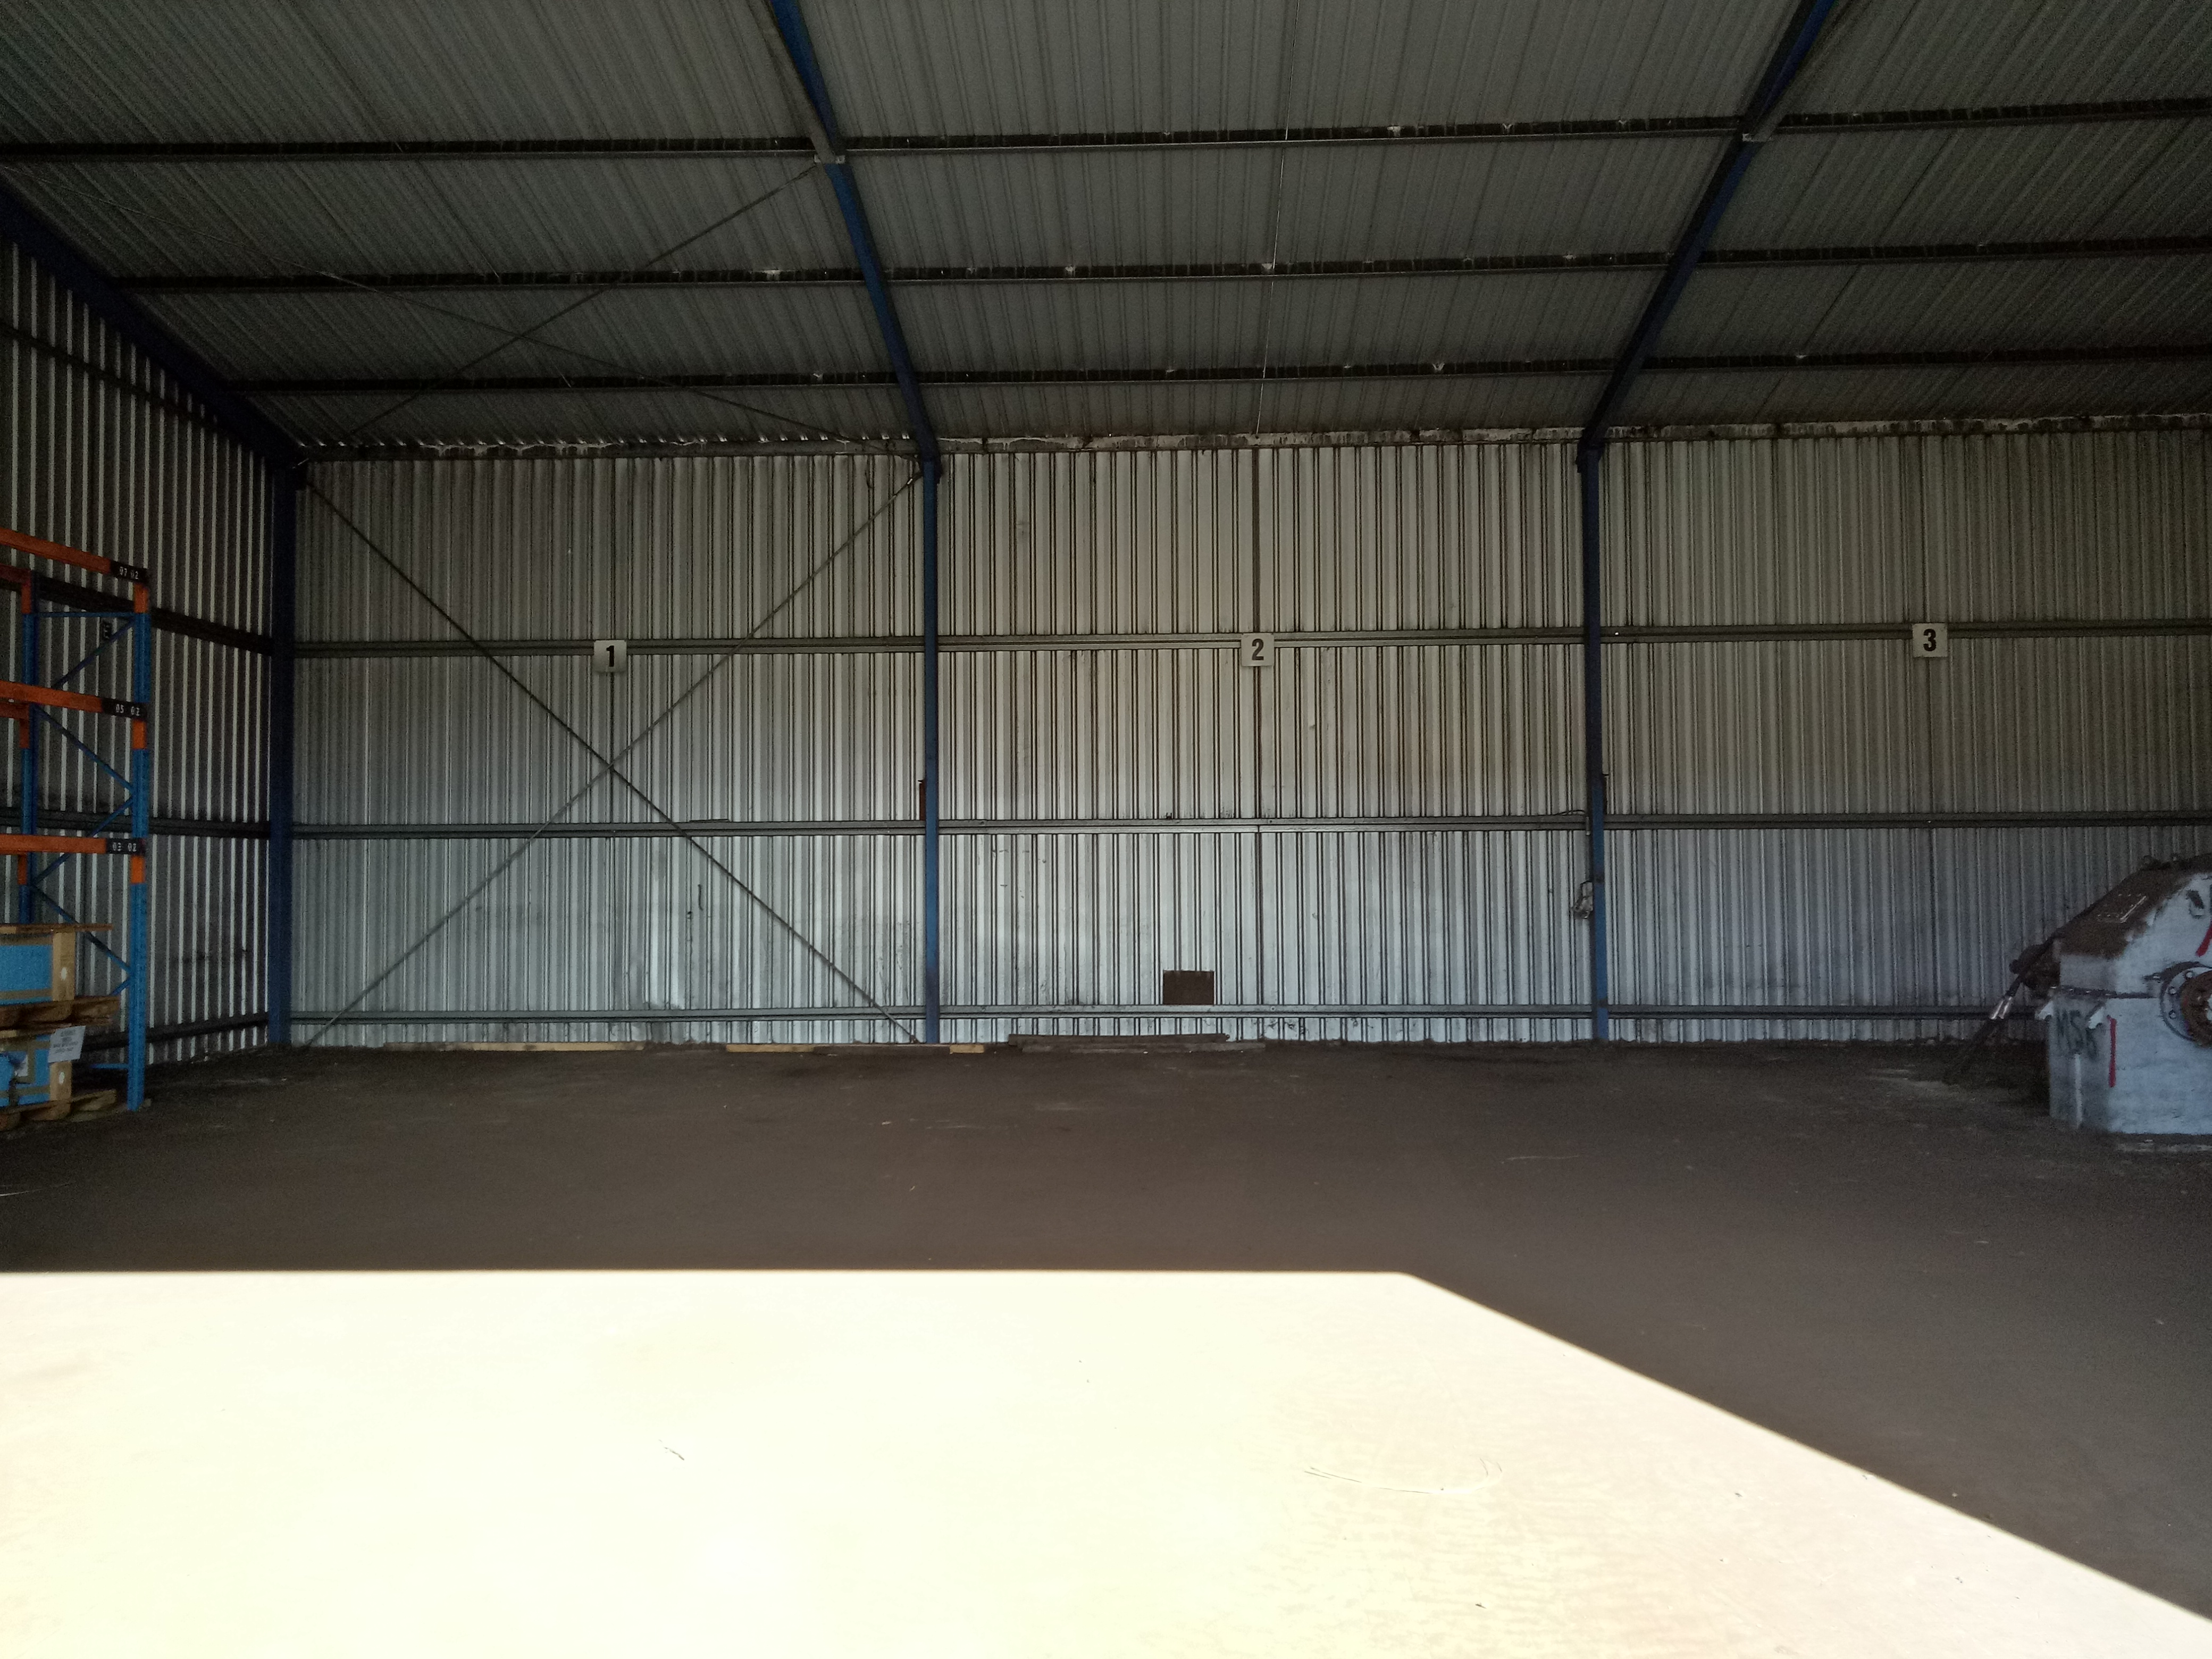
Figure 6: Shed proposed to be used for secure storage of asbestos prior to placement in the landfill

1.8 Public Comment

About 70 people attended the public meeting held on 27 November 2017 at the Morwell Bowling Club. No questions from the audience raised issues with the landfill or disposal of waste in the landfill. Questions focussed on the following issues.

- Removal of asbestos and if all asbestos was to be removed.
- The demolition process and monitoring during the demolition and removal.
- Heritage values of the Power station.

EPA received one submission from the public. No views about the landfill were expressed in the submission, the submitter was concerned solely with the demolition process and had some suggestions for the safe removal of asbestos. This submission was passed on to EBAC who are in charge of the removal of asbestos and demolition of the old power station.

1.9 Track record
EPA’s Gippsland region were requested to provide comments on the track record of EBAC.
The region commented that there is no recent regulatory history, there was a non-compliance many years ago (early 2000’s) relating to coal sludge discharge to surface waters when the site was run by a different duty holder, this risk is no longer present. The site is currently under a 53X Audit with some minor amounts of PFAS detected which is below industrial/residential criteria, this issue is under further investigation. This is reflected in EBAC’s account of their track record in 2.4.2 of their application.

1.10 Timeline of the works approval application assessment

Date | Event | Comments
29-Nov-17 | EBAC community information session | Morwell Bowling club
12-Dec-17 | Works Approval application submitted
19-Dec-17 | Non-acceptance of application Letter sent by EPA | Letter outlined requirements for application to be accepted
12-Jan-18 | Meeting to discuss application and ASD comments
19-Jan-18 | Works Approval application re-submitted
08-Feb-18 | Acceptance of application letter sent
13-Feb-18 | Referral letters sent | Letters sent to Latrobe City Council, Sustainability Victoria, EPA's EPHU, WorkSafe Victoria, GWRRG and Heritage Council Victoria
15-Feb-18 | Advertisement date | Herald Sun and Latrobe Valley Express
02-Mar-18 | First S22 notice sent | Due date 12th March
08-Mar-18 | Closing date for public comments | one submission received
29-Mar-18 | Response to first S22 notice received | Re-iterated request to consider alternative to the drainage layer
12-Apr-18 | On-site meeting in Morwell | EPA DAU and Gippsland Regional office staff met with Barry Dungey and walked over the landfill site.
30-Apr-18 | On-site meeting in Morwell | EPA and WorkSafe Victoria officers visited the EBAC site to discuss asbestos storage and handling with the project manager Barry Dungey
08-May-18 | Second S22 notice sent | ASD response to request to risk assess the applicant's request to re-consider alternative to drainage layer design was that EBAC should do this. ASD response formed basis for second S22 notice.
11-May-18 | Meeting to discuss S22 notice questions
18-May-18 | Draft response to S22 notice received
25-May-18 | ASD assessment of draft response received
30-May-18 | final response to S22 and updated application document received
30-May-18 | Works approval issued

2. Policy Framework and Assessment

The application was referred to EPA’s Applied Sciences Directorate (ASD) for assessment by their waste management experts. Additionally, EPA’s Legal Services Unit (LSU) was consulted.

2.1 Policy framework

EP Act, waste management policies and State environment protection policies (SEPPs) establish a framework to ensure that landfills are appropriately sited, designed, operated and managed to minimise risk to the environment.

An application for a landfill works approval needs to be assessed under specific threshold requirements, in addition to general works approval assessment.

Threshold issues:
The Waste Management Policy (Siting, Design and Management of landfills) (the WMP) is the most relevant environmental policy for landfills. In line with community expectations, the WMP seeks to protect people and the environment, including local amenity, from the inherent risks posed by the disposal of waste to landfill. This is achieved by providing a framework and tools to implement the wastes hierarchy consistent with the broader objective of ecologically sustainable development.

In relation to the threshold issues:

Section 20C(3)(a)(i) of the Act enables the Authority to refuse an authorisation (i.e. Works Approval) if it is inconsistent with any applicable statutory policy.

Section 50C of the EPAct

Under section 50C(1) of the EPAct, the Authority may refuse to consider an application for a works approval or an application for the issue or amendment of a licence in relation to a waste management facility if –

- The operations of the facility could be inconsistent with the State-Wide Waste and Resource Recovery Infrastructure Plan or a relevant Regional Waste and Resource Recovery Implementation Plan.
- The applicant is in breach of any relevant requirements of a schedule of existing and required waste and resource recovery infrastructure within a Regional Waste and Resource Recovery Implementation Plan.

In addition, section 50C(2) of the EP Act requires the Authority to ‘refuse to issue a works approval for a new landfill if the landfill is not provided for in the proposed sequence for the filling of available landfill sites in a relevant schedule of existing and required waste and resource recovery infrastructure within a Regional Waste and Resource Recovery Implementation Plan.’

Section 50C(3) is relevant to the application of 50C(2) in this instance
‘(3) The Authority cannot refuse to issue a works approval under subsection (2) if the landfill is privately owned and will only receive wastes that consist of substances that were owned by the owner of the site before the substances became wastes.’

Clause 15(3)(a) of the WMP requires applicants for a works approval to comply with the WMP and all other relevant State environment protection policies and waste management policies.

Clause 13(3) of the WMP requires that new landfill sites must not be established or extended into any area where an aquifer contains Segment A groundwater, unless the:
- Landfill operator satisfies the Authority that sufficient additional design and management practices will be implemented; and
- The Authority determines that regional circumstances exist that warrant the development of a landfill in the area.
Clause 16(2) of the WMP requires that all new landfill sites must deposit waste at least two metres above the long term undisturbed depth to groundwater, unless the:

- Landfill operator satisfies the Authority that sufficient additional design and management practices will be implemented; and
- The Authority determines that regional circumstances exist that warrant the development of the landfill.

2.2 Summary of assessment:

2.2.1 Considerations under s. 50C of the EPAct

Considering firstly section 50C(2) of the EP Act, in this instance section 50C (3) applies:

“The Authority cannot refuse to issue a works approval under subsection (2) if the landfill is privately owned and will only receive wastes that consist of substances that were owned by the owner of the site before the substances became wastes.”

Clearly the proposed landfill falls into this category as the landfill will be on the site owned by EBAC and will be solely for asbestos contaminated wastes generated from the demolition of the old power station on the site. SV confirmed in their submission that the application is consistent with the SWRRIP (Section 50C (1) (a)) and the GWRRG confirmed in their submission that “there is no requirement for this facility to be incorporated into the current landfill schedule within the Gippsland Waste and Resource Recovery Implementation Plan (Gippsland Implementation Plan) which was gazetted in June 2017:” (Section 50C (1)(b) and 50C (2)).

2.2.2 The level of compliance with clause 13(3) of the WMP

The proponent’s initial assessment was that the groundwater under the site was in segment B. However, the ASD assessment was initially that although the segment is likely to be segment B the proponent had supplied inadequate data to be sure of the assessment, in particular the information provided was all from the spring and early summer season. The proponent was requested through a S22 notice issued on 2 March 2018 to provide more data, particularly data from a different season. This they were able to do and ASD’s assessment was that the groundwater was segment B (Appendix 10).

2.2.3 The level of compliance with Clause 16(2) of the WMP

The groundwater level at the proposed asbestos landfill site ranges between 62.7 to 66.5 m AHD, as measured in bores GW17 B and GW17, respectively. The lowest point of the top of the landfill clay liner will be 77.6 m AHD. Therefore, the base of the landfill will be at least 11 m above the current groundwater level. The current groundwater level however is not the long term undisturbed groundwater level. The site is close to the Morwell open cut coal mine. This rather large and deep hole requires constant groundwater pumping to keep the mine dry. This has had a marked lowering effect on local groundwater levels and with the forthcoming closure and re-habilitation of the mine, groundwater levels are expected to re-bound (rise). A discussion on the likely rebound levels is provided in section 4.6.6 of the works approval application. The discussion is based upon the Hazelwood Mine Fire Inquiry report which provides information on the final resting level of a pit lake in the Hazelwood/Morwell open cut mine pit. In this report, the proposed rehabilitation of the Loy Yang and Hazelwood mines seeks to achieve ‘weight balance’ by creating a ‘shallow’ lake that partially fills the mine pit. Weight balance is the level of fill that is required to counterbalance the upward pressure of the underlying deep aquifers by downward pressure from the water and/or backfill. This has been modelled and is estimated to reach an RL of -22 m (a 38-metre-deep lake one third of the mine pit depth) after about 6 years. This is different to the final level that will be achieved which would be considerably higher, it is predicted that the lake will eventually reach RL +8 m (a 68-metre-deep lake between 50 and 60 per cent of the mine pit depth, this is estimated to take about 500 years. This is approximately 55 to 75 m below the current groundwater levels under the EBAC site. It is considered that a steep hydraulic gradient will be maintained between the groundwater levels beneath the landfill and the final pit level and that a separation distance of > 2 m will easily be maintained.
ASD have considered the information presented in the application and are in agreement with the assessment of the long-term groundwater levels in the region. ASD did have some concerns over the data provided to determine the current groundwater levels under the site in relation to the proposed landfill and requested more data and greater clarification of the levels in mAHD. This information was provided in the S22 response and was accepted by ASD (Appendix 10).

2.2.4 Compliance with “Getting Full Value” Policy

The Victorian Waste and Resource Recovery “Getting Full Value” Policy (Government of Victoria, April 2013) lists the following principles for the management of wastes (known as the waste hierarchy):
- avoidance
- reuse
- recycling
- recovery of energy
- treatment
- containment
- disposal
Landfills are mostly about the last two principles but are regarded by the policy as being a necessary part of the waste management infrastructure. In 7.3 of the policy it states that the government’s intention is that future landfills will only receive treated residual waste after processing for the recovery of all materials with economic value. The policy states that this will be achieved over time through the implementation of market based measures and the landfill levy will continue to be used as a market signal that provides incentives to resource recovery industries.
SV in their submission noted that due to the nature and health and safety issues with asbestos there is unlikely to be a viable use, and therefore consider that the proposal is generally in line with the intentions of the SWRRIP. They also encouraged the recovery of materials such as timber and concrete to the greatest extent possible, and that EPA seek comments from the GWRRG with respects to the need for this landfill to be scheduled. GWRRG confirmed in their submission that the landfill was not required to be incorporated into the landfill schedule. GWRRG also noted that: there was a shortage of suitable landfill space for asbestos in Gippsland, that the Dutson Downs facility would have insufficient space for the expected amount of waste, and that the proposed site being on the same site as the demolition would minimise risks with the handling and transport of asbestos waste.

2.2.5 Buffer requirements
The site is zoned Special Use Zone 1 (Brown Coal) under the Latrobe City Council Planning Scheme and is subject to Environmental Significance Overlay Schedule 1 (ESO1).

The site is surrounded by Industrial use zone 1 to the north west, north and east of the site, Public Use Zone (PUZ6) and Farming Zone (FZ1). The special use Zone 1 that incorporates the site extends to the west and south and incorporates the Morwell open cut. (see section 1.5). Based on the information presented, the proposal mostly complies with the buffer requirements of Table 5.2 of the BPEM for a Type 2 landfill. Bennetts Creek is the closest waterbody and runs broadly parallel to the eastern boundary of the site, it is 400m from the proposed landfill site, this meets the buffer requirements in BPEM. However, there are two commercial buildings that come within the 200m buffer required by BPEM. EPA requested (through the S22 notice of 2 March 2018) that EBAC prepare a comprehensive risk assessment on receptors due to the buildings being located within the 200m buffer zone. A risk assessment was provided in response to the notice (Appendix H of the revised application). This risk assessment was reviewed by EPA’s ASD and was considered acceptable. The conclusions of the risk assessment are:

- Two commercial buildings are located approximately 135 m from the Western boundary of landfill activity. They are not considered as sensitive receptors under the Latrobe planning scheme or the landfill BPEM.
- The nearest sensitive receptors (generally residential properties) are 600 m to the north of the landfill activity boundary.
- Based on the control measures to be implemented at the proposed asbestos landfill all risks were identified as low. Therefore, it is considered that:
- Risks to commercial buildings within the 200 m landfill buffer are considered low.
- Risks to the environment and human health from the landfill will be effectively controlled through the control measures detailed in this risk assessment and described in the asbestos landfill WAA.

The key risks that the landfill BPEM is seeking to control through buffer distances are associated with landfill gas and odour. The type of the waste to be disposed of in the landfill generates very little of either, the landfill will not take waste from offsite and measures will be put in place to ensure a low level of contamination of the inert wastes to be placed in the landfill.

2.3 Detailed designs for the landfill construction
The application contains concept designs for the landfill which is acceptable. Detailed designs will be provided, if the WA is granted and prior to starting construction of the landfill (landfill cells) in accordance with EPA licensing guidelines for landfills 1323.2

The proposed design is for a BPEM compliant liner and cap for a type 3 landfill. The landfill will comprise two below ground landfills, the main landfill (landfill A, Figure 5) will have an airspace of approximately 10,000 m³. It will be made up of four cells or compartments. The secondary landfill (landfill B, Figure X) will have an airspace of approximately 5,000 m³. It is intended that landfill B will only be constructed if the quantity of waste generated from the demolition exceeds the capacity of landfill A. The need for landfill B will not be known until demolition is underway and is regarded as a contingency measure.

The preliminary designs show that the landfill will be constructed with the following liner configurations.

2.3.1 Base and side wall liner:
The base liner construction will consist of the following (from top to the base):
- A leachate collection system.
- A compacted clay liner with a minimum thickness of 1000mm and coefficient of permeability not exceeding 1x10-⁹ m/s.
- The preparation of the sub-base.

2.3.2 Landfill cap:
A type 3 landfill cap is proposed with the following components (from bottom to top):
- Foundation layer comprised of earth material which will be spread and compacted over the wastes at least 300 mm thick..
- A clay barrier layer of at least 500 mm and a permeability of not more than 1X10⁻⁹ m/s.
- Warning visibility geotextile to provide a warning of the asbestos landfill below.
- Top soil/sub soil at least 500 mm thick.

The cap will meet the Landfill BPEM recommended slope range (5-20%) and the maximum capped height will be approximately 3.5 m above ground level. The landfill cap will be tied into the perimeter bund and will be vegetated to minimise erosion.
A final pre-settlement contour plan(s) (top of waste and top of cap) has also been provided (Appendix 14). Two versions of the top of cap contour plans have been provided, one for Landfill A only and one for Landfill A and B.

The above liner configuration is acceptable. However, detail designs must be provided prior to start construction of landfill cells. Appropriate conditions will be included in the Works Approval for this to happen.

2.3.3 Leachate collection and management

Leachate will be minimised through the following measures:
- Construction of an earthen bund around the perimeter of the landfill to prevent stormwater runoff from adjoining land from entering the cells.
- Small footprint of the landfill.
- Each cell will be separated by an earthen bund, all rain falling on a non-active cell will be managed as stormwater.
- Each cell will be filled to the final height and capped before landfilling of the next cell commences.
- The final cap will be sloped to achieve the minimum slope recommended by BPEM and will be fully vegetated.
A leachate collection system will be installed on top of the base liner. This system will comprise of 200 mm X 40 mm strip filter drains located within each of the landfill cells. These drains will drain to leachate sumps. It is proposed that leachate within the sumps will be pumped using portable surface pumps. Aggregate will be mounded over the drains.
Leachate pumped from the sumps will be stored in 1000 litre IBCs located in a bunded area next to the landfill. Leachate will be tested for presence of asbestos fibres and hydrocarbons, nutrients, heavy metals and BOD. Depending on the quality, it will be disposed of via the site’s stormwater system, licensed trade waste disposal or transported off site for disposal at an EPA licensed wastewater treatment facility. Any leachate discharged via the stormwater system will be in accordance with the water conditions of EBAC’s licence (11269).

This approach to leachate management is consistent with the landfill BPEM and is considered acceptable.

2.3.3.1 Variation to Landfill BPEM requirements for the leachate collection system

The applicant has requested a variation to the BPEM requirements for the leachate collection system. Appendix C of the landfill BPEM (Publication 788.3) lists the objectives and the required outcomes of the landfill BPEM. Section 6.3 of Appendix C lists the BPEM objective and required outcomes for the Liner and leachate collection system. The relevant BPEM objective is: To maintain groundwater quality as close as practicable to background levels. To achieve this objective, 13 required outcomes are listed. The applicant has asked for a variation to two of these required outcomes, namely:
- Drainage layer to be at least 0.3 mms thick with a hydraulic conductivity of not less than 1X10⁻³m/s.
- Drainage layer extending over the entire base of the landfill.
Instead of the drainage layer, the applicants have proposed a soil protection layer 200 mm thick to protect the underlying clay liner from vehicular damage. They have proposed this approach for OH&S reasons. The 4WD high loader that they propose to use to lift loads off the truck and place them in the landfill will need to traverse the base of the landfill. It is claimed that the 300 mm layer of aggregate would be an unstable base for the high loader to drive on and would be at risk of tipping. The applicant claims that the placement of the strip filter drains with aggregate heaped over them offers a practicable solution that reduces the operational safety risks. They claim that the proposed design will more than adequately meet the drainage requirements of the asbestos landfill, considering the very low leachate generation rates expected, low leachability of the material to be placed in the landfill, high porosity of the wastes and the short operating life of the landfill.
EPA’s ASD initial assessment of this requested variation is that it does not comply with the WMP as it does not meet all the required outcomes of the BPEM (clause 15 (3) (c)). After this initial assessment, the applicant requested EPA to re-consider their initial response in their response to the first S22 notice. EPA reconsidered the request and came to the view that even though the application was not strictly in accordance with BPEM that EPA could consider a variation if there is no increased environmental risk. The objective of the BPEM is to protect the environment from the impacts of landfilling activities and it is not intended that the BPEM stifle innovation or approaches tailored to specific circumstances. Clause 15(5) of the WMP allows EPA to consider alternative measures proposed by a landfill works approval applicant where the measures meet the requirements of subclause (3)” and “provide at least an equivalent environmental outcome to that provided by the suggested measure.”. Therefore, if an applicant has a proposal that is at variance with the BPEM but still achieves the objective of protecting the environment (in this case to maintain groundwater quality as close as possible to background levels) then EPA is prepared to consider the application on its merits.
ASD recommended to DAU that the design must meet BPEM requirements in the absence of supporting data. These concerns were also relayed to the applicant. Attention was drawn to section 6 – Best Practice Design (Publication 788.3, EPA Victoria, 2015) “Where the landfill designer believes that alternative measures can achieve the objectives and required outcomes, these should be supported by a risk assessment”.
Accordingly, EPA requested the applicant (through a S22 notice issued on 8 May 2018, Appendix 8) to justify the variations they were seeking in terms of risk to the environment.

2.3.3.2 Questions asked in the second S22 notice

- Provide justification for the use of strip filter drains in the landfill cells:

- Provide further justification for the substitution of the drainage layer with a soil protection layer:
- Please outline the OH&S risks associated with the use of the BPEM compliant aggregate layer.
- Outline how the build-up of leachate head will be prevented. The build-up of a head of leachate could compromise the integrity of the cell liner leading to failure.
- It is understood that over many decades the leachate collection systems could fail. Explain how the design requirement for the cell still be able to remove liquid from the CCL surface through natural drainage alone will be met, in the event of failure of the drains.

- Please provide supporting evidence that demonstrates how the deviations from the best practice design that you have proposed in your application will still achieve the objectives of the BPEM and do not increase the environmental risk.

2.3.3.3 Applicant response to second S22 notice and ASD assessment

The full response to the second S22 notice is provided in appendix 8 and ASD’s response in Appendix 12. To provide further evidence of the suitability of the alternative leachate collection design, the applicant’s consultants undertook HELP (Hydrological Evaluation of Landfill Performance) modelling to estimate leachate generation following final capping of the landfill. The following methodology was undertaken:
- Gather climate data for the site.
- Undertake HELP modelling to estimate infiltration of rainfall through the final cap.
- Estimate landfill leachate generation reporting to the leachate collection system.
The HELP modelling results indicated that minimal volumes of leachate will accumulate in the cell overtime, minimising the potential for leachate head to build up on the liner.

ASD’s assessment of the applicant responses to the questions in the S22 notice of 29 May 2018 are summarised below.

- Provide justification for the use of strip filter drains in the landfill cells

ASD recognize the increased performance provided by the proposed filter strip drainage in terms of drainage capacity, generally 10-15 times more efficient than material proposed in BPEM. We also consider the additional measures identified in section 4.8.4, 4.8.5 and 4.8.6 regarding leachate management and stormwater management, which would also limit the amount of leachate generated during landfilling activities. Based on this information, and the results of the HELP model, this deviation would be considered low risk and acceptable.

- Provide further justification for the substitution of the drainage layer with a soil protection layer.

- Please provide supporting evidence that demonstrates how the deviations from the best practice design that you have proposed in your application will still achieve the objectives of the BPEM and do not increase the environmental risk

The supporting evidence (HELP modelling) provided suggests infiltration rates be 40% below the recommended seepage rates as stated in BPEM, therefore it is considered to further reduce the environmental risk due to future leachate generation.

Other supporting evidence includes additional management practices proposed under sections 1.1 and 4.12 of the March 2018 report – the operating life of the landfill will be two years, with four cells to be progressively filled and capped prior to commencing filling of future cells over this period.

Leachate Generation.

It is noted the potential for leachate to generate hazardous dissolved or suspended solids during both landfilling activities, and post rehabilitation, is considered low based on the following lines of evidence provided:

During Landfilling activities: The material entering the proposed landfill will be handled in accordance with publication 611.2 (EPA Victoria, June 2017), and as described in section 4.12.2 of the GHD report (March 2018). These materials will either be double wrapped in polythene plastic or contained in 44 gallon drums, therefore eliminating the leachability pathway of the waste in the short term. Careful placement in the landfill will be critical to ensure that the polythene plastic is not ripped or drums damaged during deposition.

Post Capping: Even if/when degradation of the plastic material and drums containing ACM and (possible) co-mingled materials occurs. Potential for leachate generation is considered low due to evidence provided in the HELP model.

Other concerns identified previously by ASD were related to longevity of the leachate system collection, and the ability to function satisfactorily in the event of component failure (i.e. drainage pipe failure) after rehabilitation. Based on HELP modelling, ASD consider the risk of drainage failure to be low.

ASD consider the risk assessment contained in the 18 May 2018 response satisfactorily addresses all the concerns previously raised by ASD, and the risk to the environment due to these deviations would be considered low.

2.3.3.4 Conclusion

In conclusion EPA notes that the applicant conducted a risk assessment in accordance with the general method in Appendix 2 of EPA publication 1323.3. Risks were assessed for both a Type 3 BPEM compliant liner and leachate collection system and the alternative design proposed by the applicants in the Works Approval Application.
Low risks were identified for the proposed asbestos landfill liner and alternative leachate collection system equivalent to the type 3 BPEM compliant liner and leachate collection system. The proposed alternative design is considered acceptable.

2.3.4 Stormwater management

An earthen bund will be constructed around the landfill to prevent stormwater from surrounding land running into the landfill cells. The cells will be filled starting at the northern end of the landfill. Rainwater falling into the active cell will be treated as leachate and managed accordingly. Non-active cells will not be connected into the leachate drainage system and any stormwater accumulating in them will be pumped out into the site’s stormwater pond. Prior to discharge to Bennett’s Creek the water quality in the settlement pond is tested to assess if it meets the discharge limits in EBAC’s EPA licence (11269). As filling of the cells progresses and a non-active cell becomes active it will be connected to the leachate drainage system.
After landfilling is completed the cells will be capped. The cap will be tied into the earthen bund around the landfill and will be sloped at a 5% grade (the BPEM) minimum. Because of the small area of the landfill and the minimum grades it is proposed that stormwater simply be allowed to run off the cap and dissipate onto surrounding EBAC land.

This approach to stormwater management is consistent with the landfill BPEM and is considered acceptable.

2.3.5 Establishment and licensing of the landfill
Following approval by EPA, an EPA licence will be granted for the asbestos landfill as the landfill will be a scheduled premise under the Environment Protection (Scheduled Premises) Regulations 2017. The licence will contain standard conditions addressing such areas as waste acceptance and treatment, air and water discharges, noise and odour emissions. The licence will remain in force for the entire operation of the landfill and until such time as the landfill is closed and re-habilitated in accordance with the WAA, the Landfill BPEM and other EPA requirements. Before construction of the first cell the proponents will be required to submit detailed plans and designs for EPA approval in accordance with the landfill licensing guidelines (Publication 1323.3). Following closure and rehabilitation the operator of the landfill may wish to surrender the licence. A Post Closure Pollution Abatement Notice (PCPAN) will be issued by EPA. The PCPAN will contain a number of conditions that the holder of the PCPAN has to meet to manage environmental risks during the aftercare period of the landfill.

2.3.6 Removal and handling of waste
The proposed demolition of the former Morwell Power Station and possibly the Briquette Factory is expected to generate between 10,000 – 15,000 m³ asbestos contaminated waste (ACM). This will include both friable (Class A) and Non-friable(Class A) ACM including lagging, sheeting, refractories and asbestos gasket contaminated steel. The bulk of the ACM is expected to be asbestos cement sheeting. Asbestos gaskets that are potentially contaminated with hydrocarbon will be washed in a bunded area before being wrapped and placed in the landfill. It is intended that all other material associated with the demolition will be removed from site for recycling or disposal. Potentially recyclable materials that are bonded to asbestos will be disposed of in the landfill as it is considered too risky to separate them from the bonded asbestos. Non-asbestos wastes include steel from asbestos contaminated gaskets, bricks with asbestos adhered to them, 44 gallon steel drums, plastic wrapping and wooden pallets. Note the last three items are not waste as such but materials that are required to comply with WorkSafe and EPA requirements for the safe handling and containment of asbestos. The landfill will be licensed to accept ACM waste generated at the premises only, no other wastes including any wastes from external sources will be accepted. An inspection protocol will be developed to ensure that only wastes approved for disposal are accepted.
Asbestos removal is strictly controlled in Victoria via codes of practice and safety regulations (see section 1.7). Removal must be carried out by licensed contractors. Class A (friable) asbestos will be double wrapped in plastic and then sealed into 44 gallon steel drums and then placed on pallets. Class B (non-friable) asbestos will be double wrapped in plastic and placed on pallets. The pallets of ACM will be stored in a secure steel shed (on site). After a sufficient quantity is accumulated the pallets of waste will be transported by truck to the landfill where they will be unloaded and placed in the landfill (see section 1.7). At the end of each day the waste in the landfill will be covered with soil.

2.3.7 Waste transport
All waste that will be generated on-site and disposed of on-site will be transported on internal roads and will not require Waste transport permits or certificates.

2.3.8 Rehabilitation & aftercare management
The landfill will be capped with a BPEM compliant cap (see section 2.3.3). Following completion of landfilling operations, the temporary security fencing and gate will be removed and a farm style post and wire fence will be erected around the landfill, appropriate signage will be put in place.

The landfill will be GPS marked and recorded on both EPA and council waste data bases. The landfill part of the site will not be used for any purpose in the future. EBAC propose to manage this through including a Section 173 agreement on the Certificate of Title, which places restrictions on how you can use the land. The Section 173 agreement is listed as a restriction on Certificate of Title and is a contract between the Council and a landowner, but may also include other parties.
EBAC submitted an Environmental Management Plan (EMP) with the original application, this original plan was for the EBAC site and was prepared before the landfill proposal and did not specifically address the landfill. EPA requested (through the first S22 notice) EBAC to prepare an updated plan for the landfill site, this updated plan was reviewed by EPA’s ASD experts (Appendix 10) and was considered acceptable. A monitoring program has been proposed for the aftercare period this will include monitoring the condition of the cap, leachate collection and stormwater drains and rectification actions will be undertaken if required. Other monitoring that will occur at the site include:
Groundwater
As part of the 53X audit groundwater monitoring is being undertaken to assess the impacts of historical operations at the site. A groundwater monitoring network of 21 bores exists at the site. No impact from the asbestos waste on groundwater is expected.
Leachate
Leachate levels will be checked bi-annually for compliance with BPEM compliance levels (see section 2.3.3 for further details).
Surface water
In the aftercare period stormwater will be dissipated through overland flow. Stormwater runoff at the site is currently collected in a settlement pond (see section 2.3.5 for details on how stormwater will be managed during the active period of the landfill). Before discharge from the settlement pond water quality is tested to assess if it meets the discharge limits specified in EBAC’s EPA licence (licence no 11269).
Dust, Asbestos fibres and Noise
Monitoring is not required during the aftercare period.

2.4 Landfill gas management

The wastes being placed in the landfill would produce little if any landfill gas. Installation of a landfill gas collection and management system is not required.

2.5 Odour and dust management
2.5.1 Odour emissions
The wastes are not odorous and odour is not an issue.

2.5.2 Dust emissions
The landfill is not expected to be a significant source of dust once capped. During construction and operation there is some potential for dust generation from construction, haul roads and placement of cover material. Best practice measures to control dust include regular watering of unsealed roads. The landfill is situated 600 m from the nearest sensitive receptor and the final cap will be vegetated as soon as practicable.

2.5.3 Asbestos fibre emissions
The risk of asbestos fibre release is greatest during the asbestos removal activities. Once the asbestos is wrapped the risk reduces considerably and reduces further once it is placed in the landfill and capped. After capping there will be no asbestos fibre release unless the landfill is disturbed and the wastes exposed. WorkSafe Victoria is responsible for all aspects of asbestos removal and handling through the administration of the Occupational Health and Safety Act 2004 - this includes Part 4.4 - Asbestos of the Occupational Health and Safety Regulations 2017 (See WorkSafe referral response in 1.7).

Wastes will be double wrapped in plastic and class A wastes will be further containerised by sealing them in steel 44 gallon drums. After wrapping, the wastes will be placed in a lockable steel shed which will be signed to warm of the asbestos wastes stored within. Once sufficient wastes for one day of activity of placing them in the landfill have been stockpiled in the shed the waste swill be moved and placed in the landfill and covered with soil on the same day. The landfill will be progressively capped cell by cell.

EBAC will be employing an occupational hygienist to oversee the removal of asbestos from the power station and the placement in the landfill. An asbestos fibre monitoring program will be implemented for the duration of the operation. All asbestos removal must be carried out by a licensed contractor (see section X). During the removal and disposal to landfill operations EBAC will:
- Employ an occupational hygienist to oversee the operation.
- Progressively cap the landfill.
- Implement the cap inspection and maintenance plan.
- Implement the asbestos fibre monitoring program, including monitoring stations around the perimeter of the premises and the occupational hygienist will take random samples for fibre counts.

2.6 Greenhouse gas emissions

SEPP (Air Quality Management) (SEPP AQM), requires that generators of greenhouse gas emissions avoid and minimise emissions in accordance with the waste hierarchy, pursue continuous improvement and apply best practise to management of emissions. Applicants for a works approval are required to comply with the more detailed requirements in the Protocol for Environmental Management – Greenhouse gas emissions and energy efficiency in industry (the PEM).

The PEM outlines the following requirements for applicants applying for works approval:
- Describe the proposed works in relation to energy use and GHG emissions.
- Include energy consumption and any non-energy related GHG emissions
- Discuss best practice energy use and GHG emissions.
EBAC reviewed potential sources of greenhouse gas emissions and calculated their emissions. The main contributors to emissions was due to fuel usage by trucks and machinery at the site. Electricity usage by pumps used to pump stormwater and leachate were the next main source of emissions. The total calculated emissions associated with the construction, filling and operation of the landfill site were 10.2 tCO2-e. Applicants are only required to identify and implement best practice with respect to activities that are the subject of the application if emissions are greater than 100 tCO2-e.

2.7 Monitoring
A preliminary monitoring program has been developed as a part of the Environmental Management Plan (EMP). The monitoring program covers the operating, post closure and aftercare periods and has been assessed by ASD as being acceptable. Details of the aftercare monitoring are in section 2.5, leachate monitoring section 2.3.3, and stormwater monitoring section 2.3.5. and asbestos fibre monitoring and monitoring of the removal operation in section 1.7.

2.8 Financial Assurance
EBAC have submitted with their application preliminary financial assurance estimates for the operational and closure and aftercare phases of the landfill operation. The estimates were prepared in accordance with EPA publication 1596.1. EBAC will engage with EPA to agree upon an accepted type of financial assurance after the works approval is approved. It will be a condition of the works approval that EBAC prepare a financial assurance proposal acceptable to EPA.

3. Recommendation
Based on the information provided, the application meets the relevant legislation, in particular, the relevant provisions of the EP Act, Environment Management Policy (Siting, Design and Management of Landfills) and the BBPEM requirements. The granting of the Works Approval is recommended. However, the approval should be subject to the following (or similar) conditions.

4. Works Approval Conditions

WA_G1
Subject to the following conditions, this approval allows the construction of the following works and associated equipment Construction of a Type 3 landfill as defined in EPA Publication 788.3, August 2015, Best Practice Environmental Management: Siting, Design, Operation and Rehabilitation of Landfills, the landfill will accept asbestos waste from the demolition of the Morwell Power Station, Briquette factory and other structures on the site. The asbestos waste will include both Class A and Class B asbestos plus other solid waste that cannot be safely separated from the asbestos waste such as bricks, concrete and steel.

WA_G2
The works must be constructed in accordance with the application accepted on 19 Jan 2018 as augmented or amended by additional information received on 3 April 2018 and 18 May 2018 in response to Section 22 notices issued on 2 March 2018 and 8 May 2018 and the updated application document received on 29 May 2018.

WA_G3
This approval will not take effect until any permit which is required under the Planning and Environment Act 1987 has been issued by the Responsible Planning Authority.

WA_G4.1.1
This works approval will expire:
a) on the issue or amendment of a licence relating to all works covered by the works approval; or
b) on the issue of written notification from EPA confirming that all works covered by the works approval are complete and that no licence or licence amendment is required to operate the works; or
c) two years from the date of issue unless the works have been commenced by that date to the satisfaction of EPA.

WA_W1
Before commencing construction of the following components of the works, you must provide to EPA a report or reports with the plans and specifications of those components, including details of: a) any landfill cell, cap or leachate pond which must be designed and constructed in accordance with the procedures outlined in EPA Publication 1323.2 (Landfill Licensing Guidelines); b) the plans, technical specifications and CQA plan must comply with EPA Publication 788.3 Best Practice Environmental Management (Siting, Design and Management of Landfills) or as otherwise approved by EPA, and c) the plans, technical specifications and CQA plan must be assessed by an environmental auditor appointed under the Environment Protection Act 1970 as per the Landfill Licensing Guidelines (EPA Publication 1323.2) prior to submission to EPA.
WA_W15
During construction, unacceptable noise (including vibration) must not be emitted beyond the boundaries of the premises.

WA_W16
During construction, stormwater discharged from the premises must not be contaminated with waste.

WA_W17
All construction activities must be undertaken in accordance with EPA Publication 480 “Environmental Guidelines for Major Construction Sites”, as amended from time to time.

WA_W2
You must not commence construction of those parts of the works for which reports are required by condition WA_W1 until written EPA approval of those reports has been received.

WA_W3
Where any reports specified in condition WA_W1 and approved by EPA differ from the application, the works must be constructed in accordance with those approved reports.

WA_W4
You must notify EPA when the construction of the works covered by this approval has been commenced.

WA_W5
You must notify EPA when the construction of the works covered by this approval has been completed.

WA_R1
At least two weeks before the commencement of any commissioning, you must provide to EPA a report that include(s): an environmental audit report, under S53V of the EP Act, on the level of compliance of construction in accordance with EPA requirements

WA_R4
Before the commencement of any commissioning, you must provide, to the satisfaction of EPA, a report that includes: a financial assurance proposal, in accordance with Section 67B of the Environment Protection Act 1970 and acceptable to the EPA

WA_R5
You must not commence operation of the works until written EPA approval of the reports required by condition(s) R1 and R4 has been received.

Report date
Date: | 29 May 2018

APPENDIX 1. Submission from Latrobe City Council
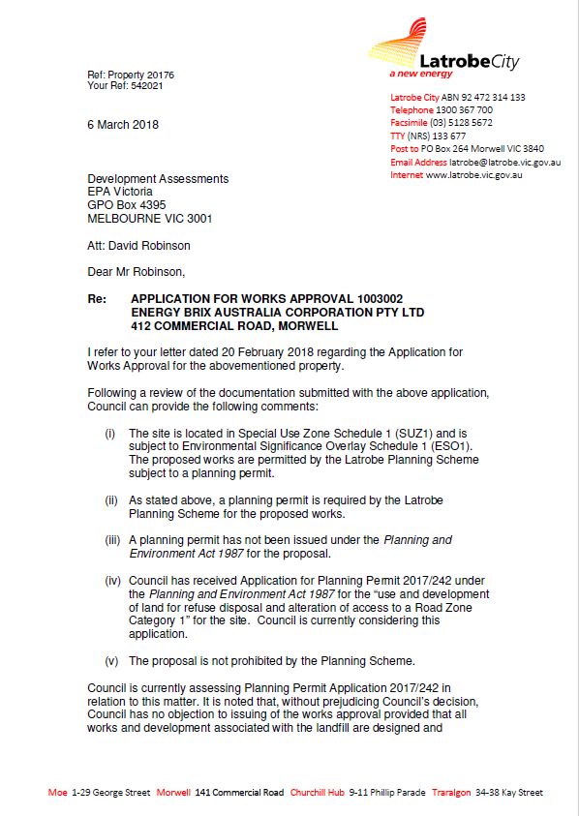

Appendix 1 continued: Submission from Latrobe City Council
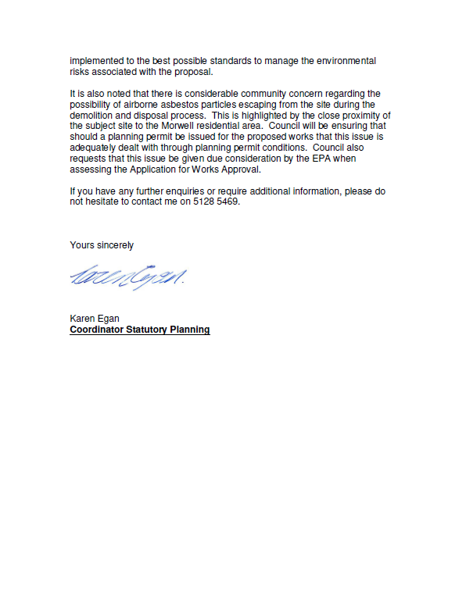

APPENDIX 2. Submission from Sustainability Victoria
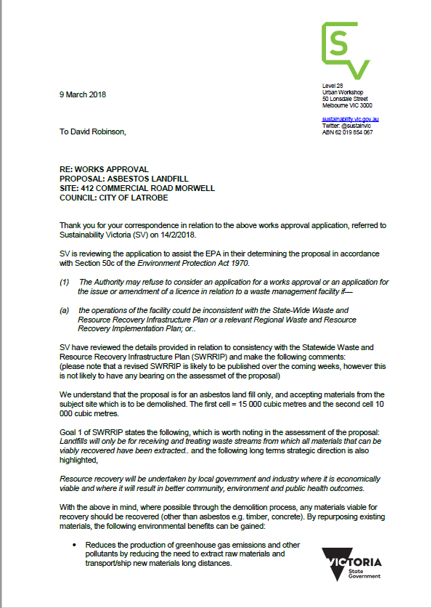

APPENDIX 2 Continued: Submission from Sustainability Victoria
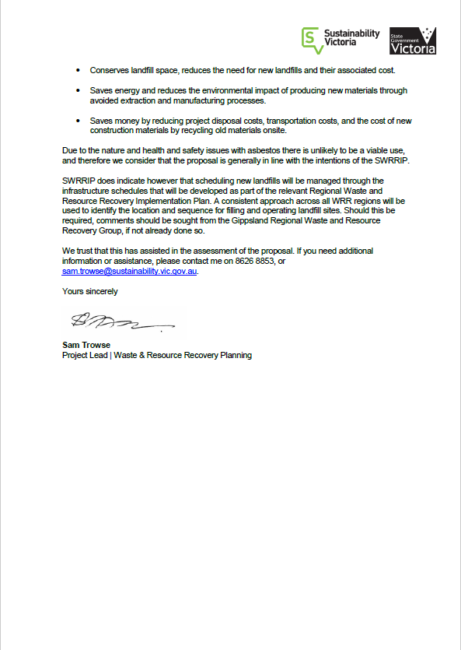

APPENDIX 3. Submission from Gippsland Waste and Resource Recovery Group (GVWRRG)
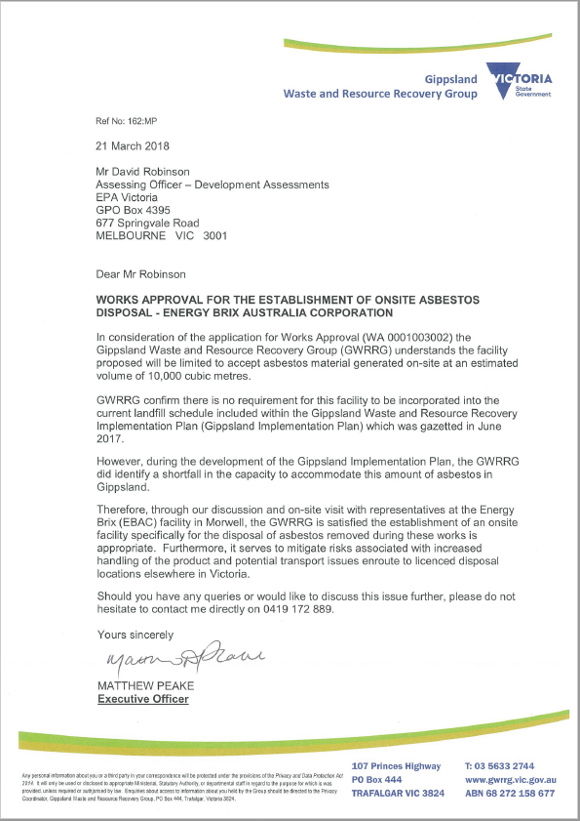

APPENDIX 4. Submission from EPA’s Environmental Public Health Unit (Department of Health and Human Services)
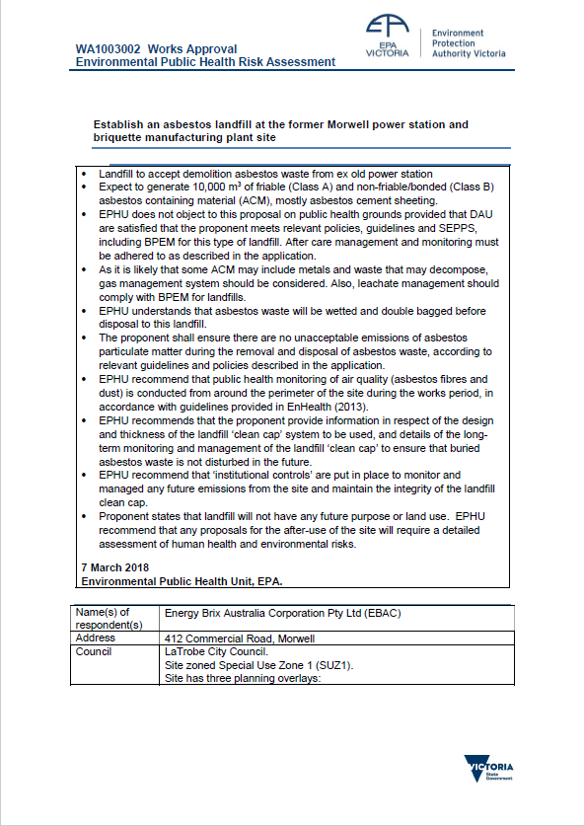

APPENDIX 4 Continued: Submission from EPA’s Environmental Public Health Unit (Department of Health and Human Services)
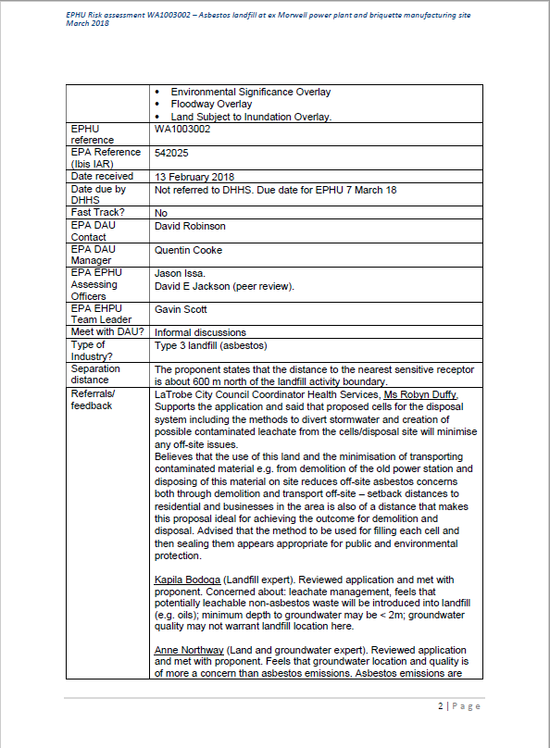

APPENDIX 4 Continued: Submission from EPA’s Environmental Public Health Unit (Department of Health and Human Services)
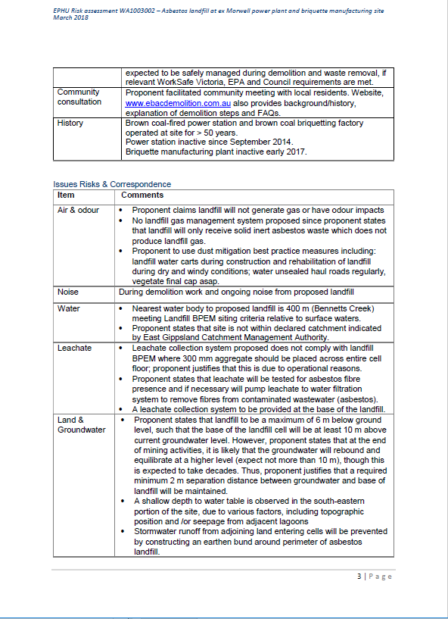

APPENDIX 4 Continued: Submission from EPA’s Environmental Public Health Unit (Department of Health and Human Services)
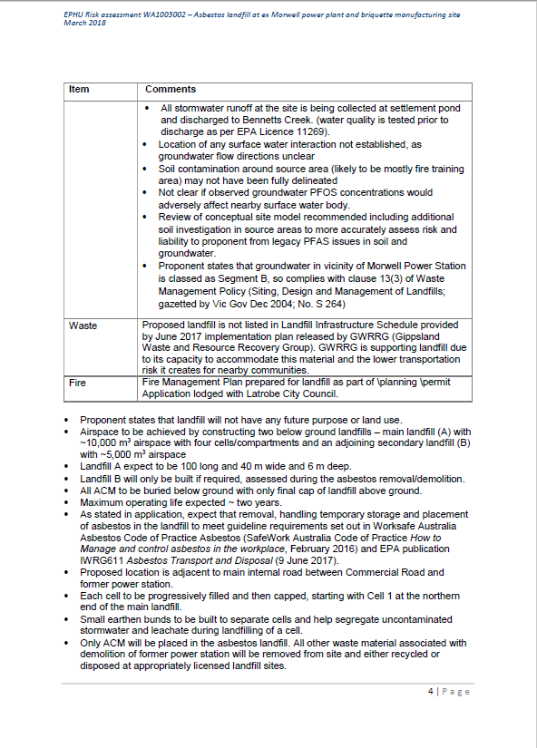

APPENDIX 4 Continued: Submission from EPA’s Environmental Public Health Unit (Department of Health and Human Services)
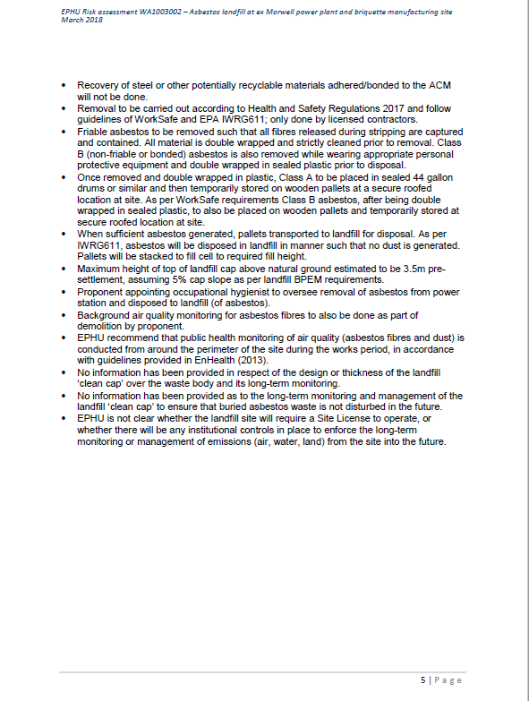

Appendix 5: Responses from WorkSafe Victoria
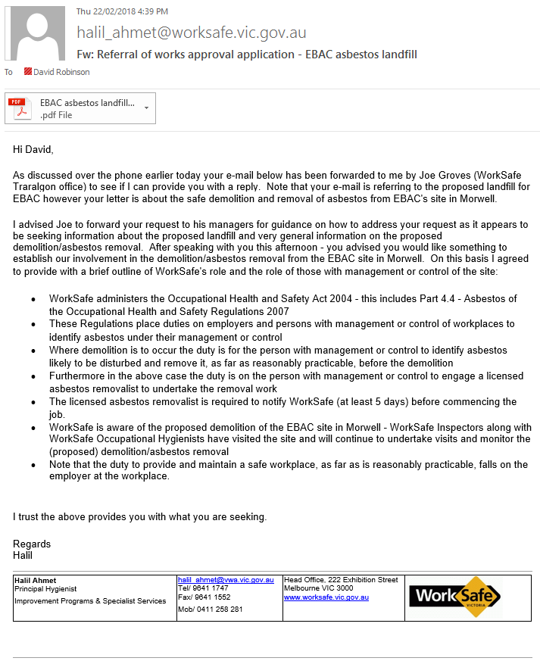

Appendix 5 Continued: Responses from WorkSafe Victoria
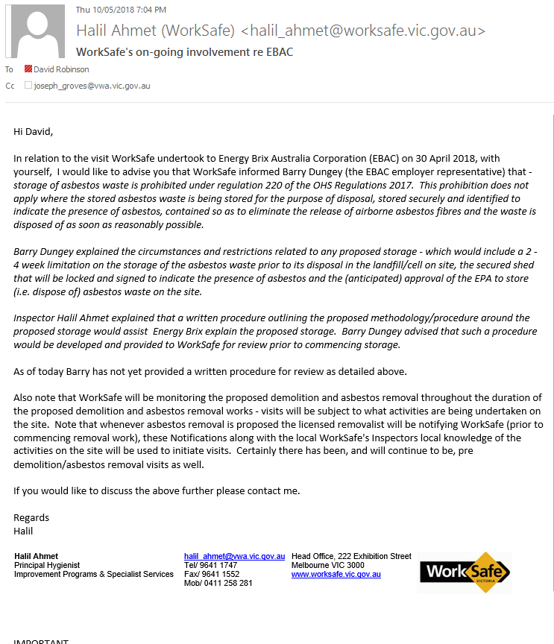

APPENDIX 6: ASG assessment of initial application 19 December 2017
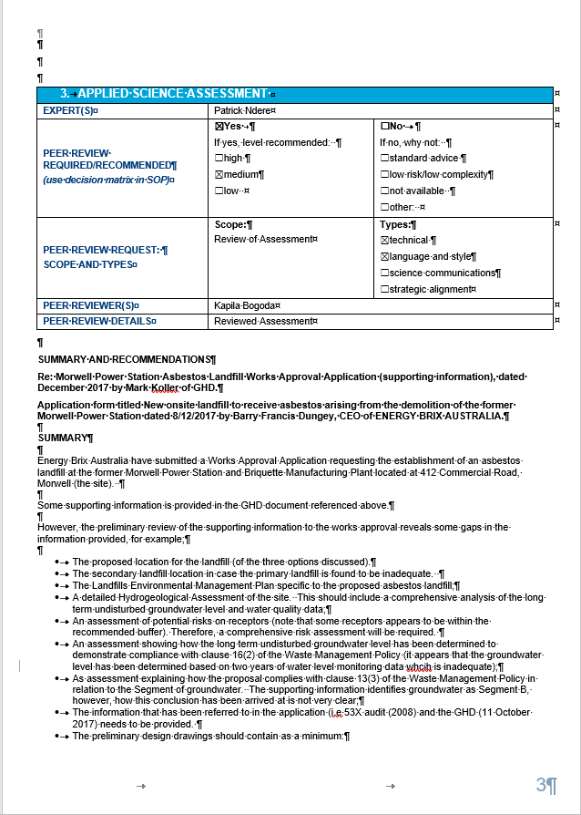

APPENDIX 6 Continued: ASG assessment of initial application 19 December 2017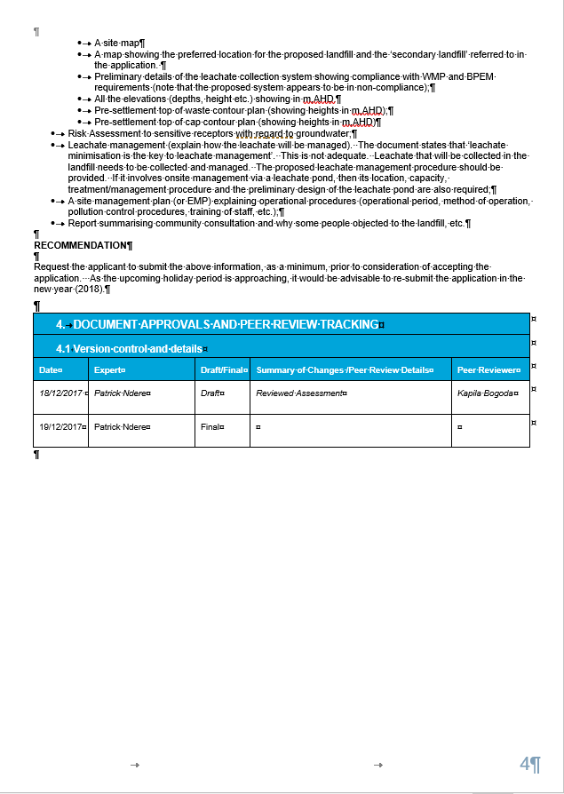

APPENDIX 7: ASD response to final application
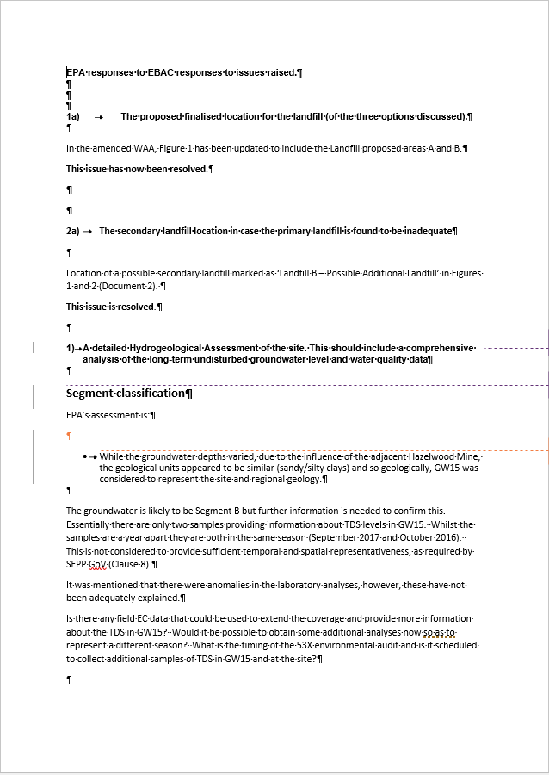
APPENDIX 7 Continued: ASD response to final application
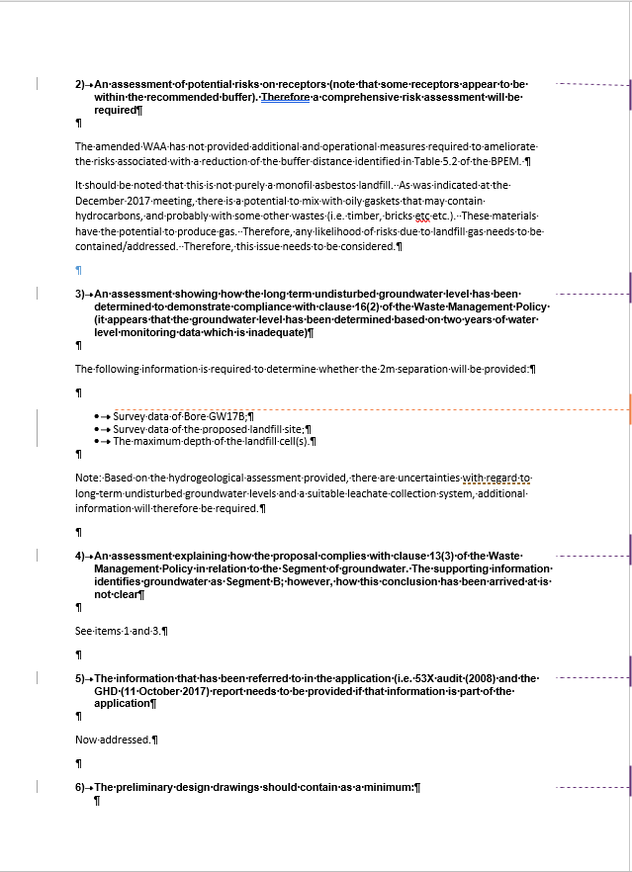

APPENDIX 7 Continued: ASD response to final application
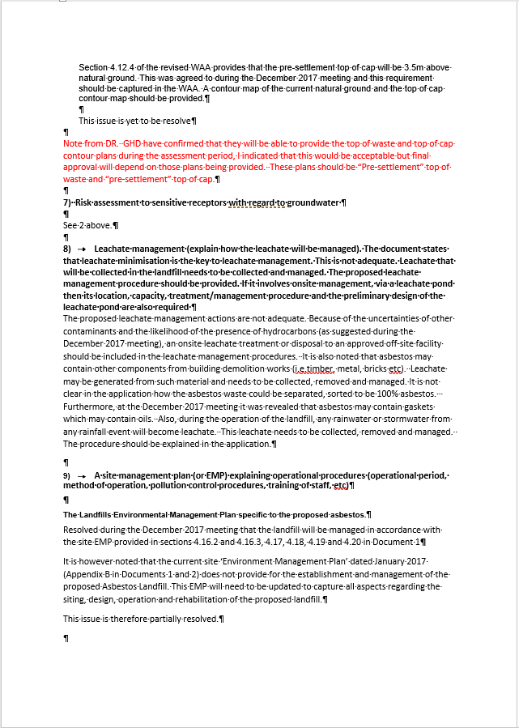

APPENDIX 8: Section 22 Notices

Notice 1: Issued 2 March 2018
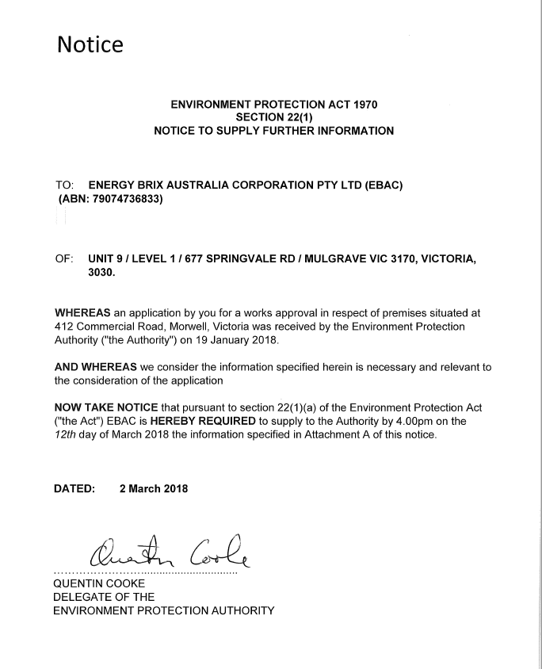

APPENDIX 8 Continued: Section 22 Notices
Notice 1: Issued 2 March 2018
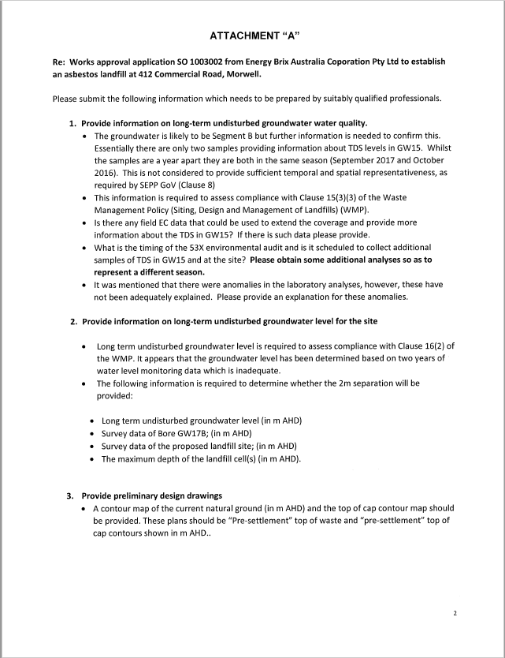

APPENDIX 8 Continued: Section 22 Notices
Notice 1: Issued 2 March 2018
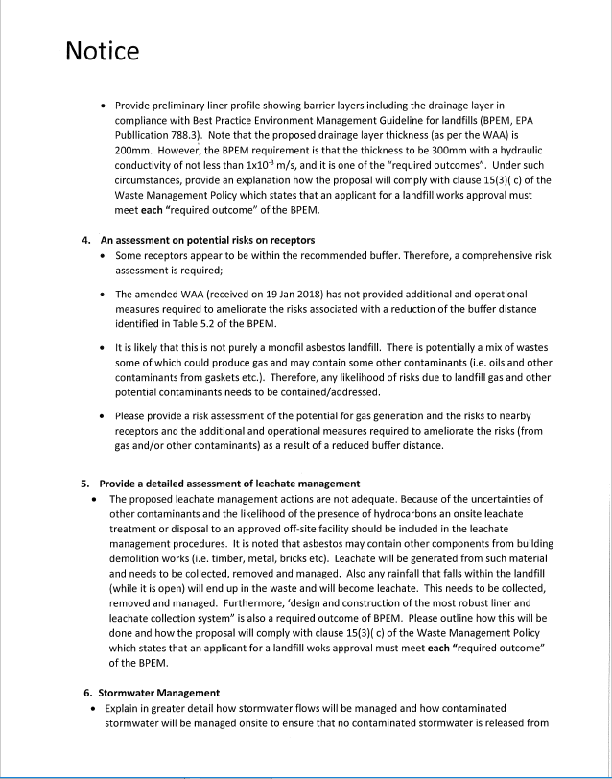

APPENDIX 8 Continued: Section 22 Notices
Notice 1: Issued 2 March 2018
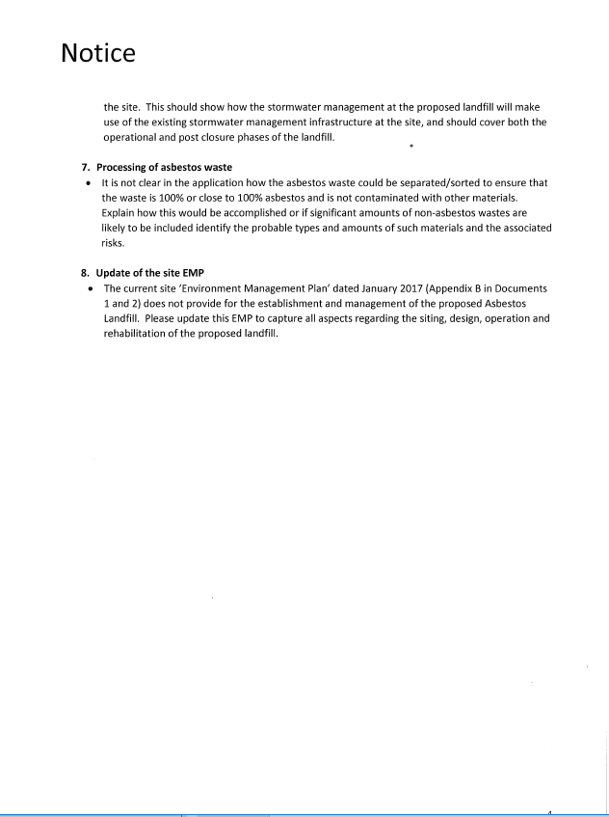

ENVIRONMENT PROTECTION ACT 1970
APPENDIX 8 Continued: Section 22 Notices

Notice 2: Issued 8 May 2018

SECTION 22(1)
NOTICE TO SUPPLY FURTHER INFORMATION

TO: energy brix australia corporation pty ltd (EBAC)
(ABN: 79074736833)

OF: UNIT 9 / LEVEL 1 / 677 SPRINGVALE RD / MULGRAVE VIC 3170, victoria, 3030.

WHEREAS an application by you for a works approval in respect of premises situated at
412 Commercial Road, Morwell, Victoria was received by the Environment Protection
Authority ("the Authority") on 19 January 2018.

AND WHEREAS we consider the information specified herein is necessary and relevant to the consideration of the application

NOW TAKE NOTICE that pursuant to section 22(1)(a) of the Environment Protection Act
("the Act") EBAC is HEREBY REQUIRED to supply to the Authority by 4.00pm on the
9th day of May 2018 the information specified in Attachment A of this notice.

DATED: 08 May 2018

...............................
QUENTIN COOKE
DELEGATE OF THE
ENVIRONMENT PROTECTION AUTHORITY

APPENDIX 8 Continued: Section 22 Notices

Notice 2: Issued 8 May 2018

ATTACHMENT “A”

Re: Works approval application SO 1003002 from Energy Brix Australia Coporation Pty Ltd to establish an asbestos landfill at 412 Commercial Road, Morwell.

Please submit the following information which needs to be prepared by suitably qualified professionals.

- Provide justification for the use of strip filter drains in the landfill cells.
The use of filter strip drainage is not normally recommended in landfill cells as it does not support on-going maintenance such as inspection and cleaning and is a higher risk of premature failure due to clogging.

- Provide further justification for the substitution of the drainage layer with a soil protection layer.
- Please outline the OH&S risks associated with the use of the BPEM compliant aggregate layer.
- Outline how the buildup of leachate head will be prevented. The buildup of a head of leachate could compromise the integrity of the cell liner leading to failure.
- It is understood that over many decades that leachate collection systems could fail. Explain how the design requirement for the cell to still be able to remove liquid from the CCL surface through natural drainage alone will be met, in the event of failure of the drains.

- Please provide supporting evidence that demonstrates how the deviations from the best practise design that you have proposed in your application will still achieve the objectives of the BPEM and do not increase the environmental risk.

APPENDIX 9: Section 22 Notices EBAC response to notice 1
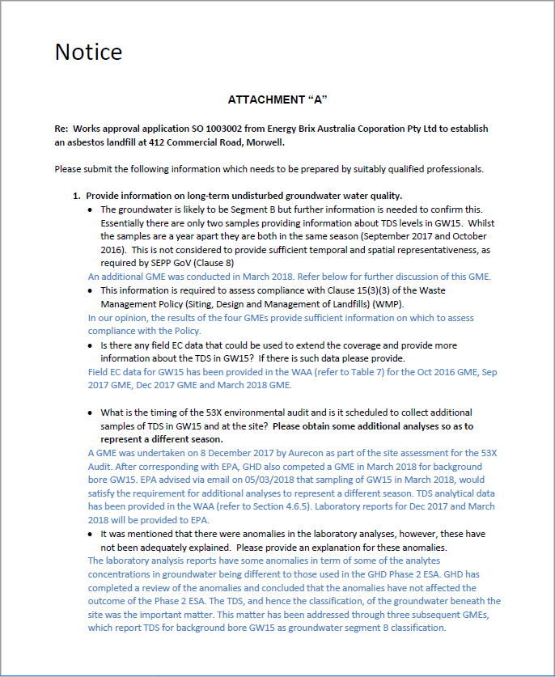

APPENDIX 9 Continued: Section 22 Notices EBAC response to notice 1
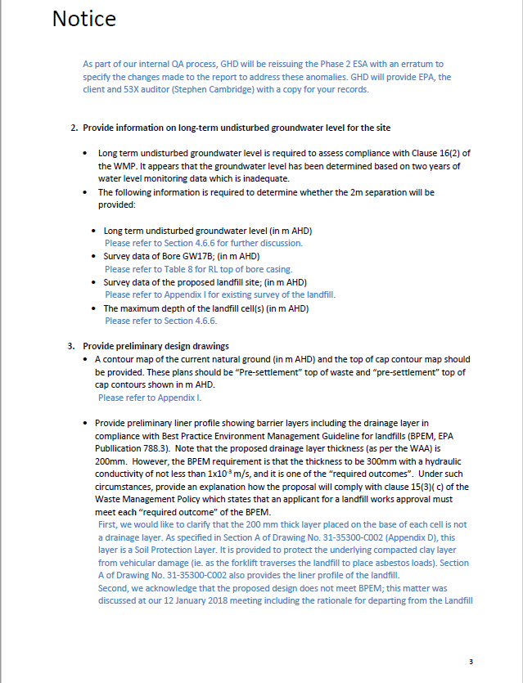

APPENDIX 9 Continued: Section 22 Notices EBAC response to notice 1
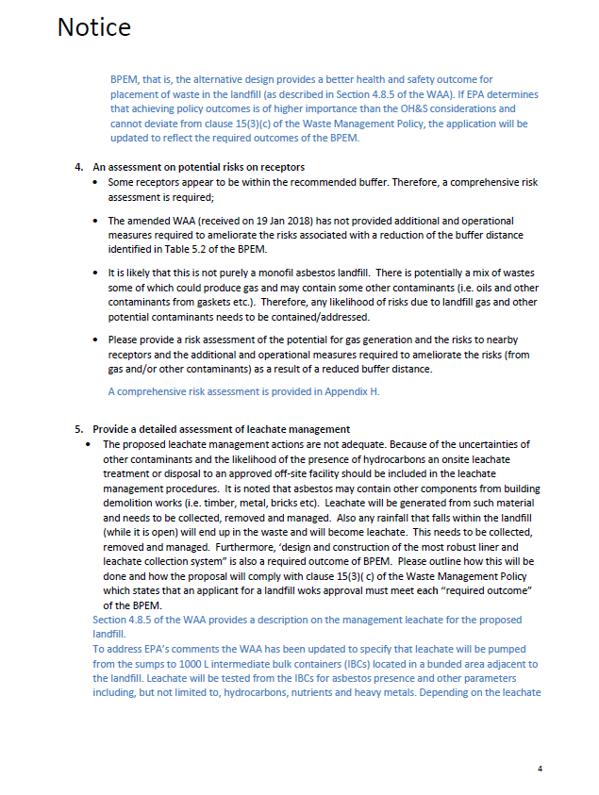

APPENDIX 9 Continued: Section 22 Notices EBAC response to notice 1
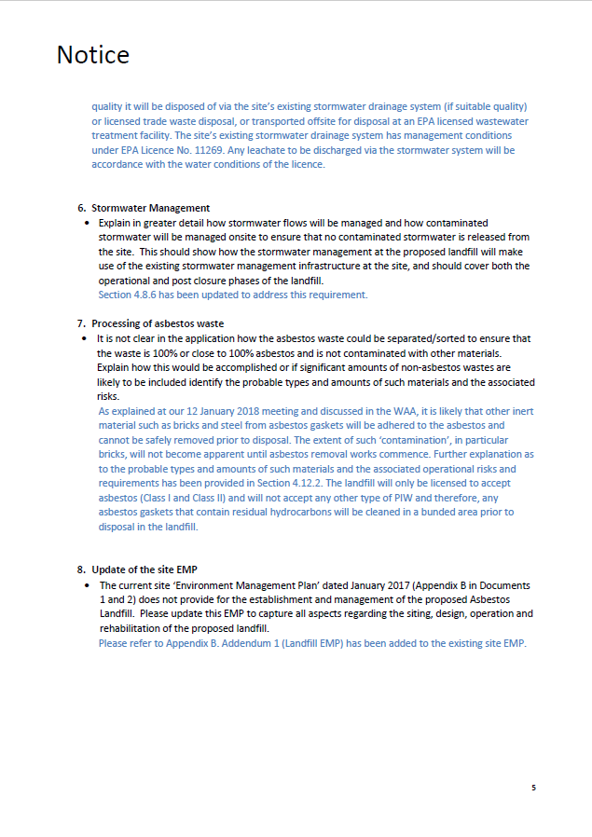

APPENDIX 9 Continued: Section 22 Notices EBAC response to notice 1
List of supporting documents
1. 31-35300-C011-RA revised contour plan.PDF Top of waste contour plan
2. 31-35300-C012-RA revised contour plan.PDF Top of cap Cell A
3. 31-35300-C013-RA revised contour plan.PDF Top of cap Cell A and B
4. 576879-W_report.pdf Analysis results for groundwater 8 Dec 2017.
5. 3134501-REP-2_Phase 2 ESA.pdf Phase 2 Environmental site assessment, March 2018.
6. 3135300-RPT-2WAA Energy Brix Australiaq.pdf Updated Works Approval application
7. EM1804172-0-COA analysis results.pdf Certificate of analysis groundwater March 2018.

APPENDIX 10: ASD Assessment of EBAC response to S22 Notice 1

- APPLIED SCIENCE – ADMINISTRATIVE INFO
EXPERT(S) | Kapila Bogoda
INITIAL CALL TO DAU DATE
QUALITY OF DAU REQUEST | Please start a new row in this spreadsheet
CLOSING CALL TO DAU DATE
- APPLIED SCIENCE ASSESSMENT – ADVICE AND SUMMARY
DOCUMENTS REFERENCED

- The response sent by the client (Energy Brix) in reply to the s.22 notice issued by EPA
- The report titled “Energy Brix Australia, Former Morwell Power Station, Phase 2 Environmental Site Assessment”, dated March 2018 prepared by GHD.
- Revised Works Approval Application, dated March 2018

ADVICE

The client’s response does not adequately address all of the issues raised in s.22 notice or the response is not acceptable.

Please see the following comments (in red) in reply to the client’s response for the s.22 Notice. Comments are in order of the items listed in the notice. The client’s response is in blue.

- Provide information on long-term undisturbed groundwater water quality?

The response is acceptable. No further comments.

- Provide information on long-term undisturbed groundwater level for the site?

The response is acceptable. No further comments.

- Provide preliminary design drawings

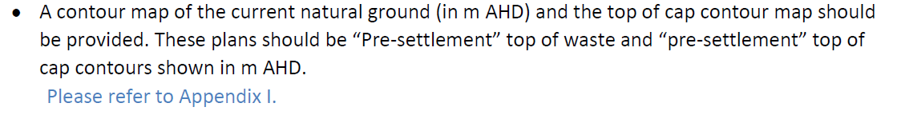

The response is inadequate and not acceptable.

Appendix 1 of the revised application has some drawings. However, they are incomplete. See below:

Drawing No: 31-35300-C011- Top of waste contour map: This drawing has some contours shown. However, contour units have not been provided. The contours without units are meaningless. Contours should have units shown and they should be in m,AHD. Please refer to s.22 item 3.

APPENDIX 10 Continued: ASD Assessment of EBAC response to S22 Notice 1
Drawing No: 31-35300-C012- Top of cap contour map: This drawing has cap contours. However, contour do not have units. The contours without units are meaningless. Contours should have units shown and they should be in m,AHD. Please refer to s.22 item 3.

Drawing No: 31-35300-C013- Top of cap contour map, Cell A & B: This drawing has cap contours. However, contour do not have units. The contours without units are meaningless. Contours should have units shown and they should be in m,AHD. Please refer to s.22 item 3.

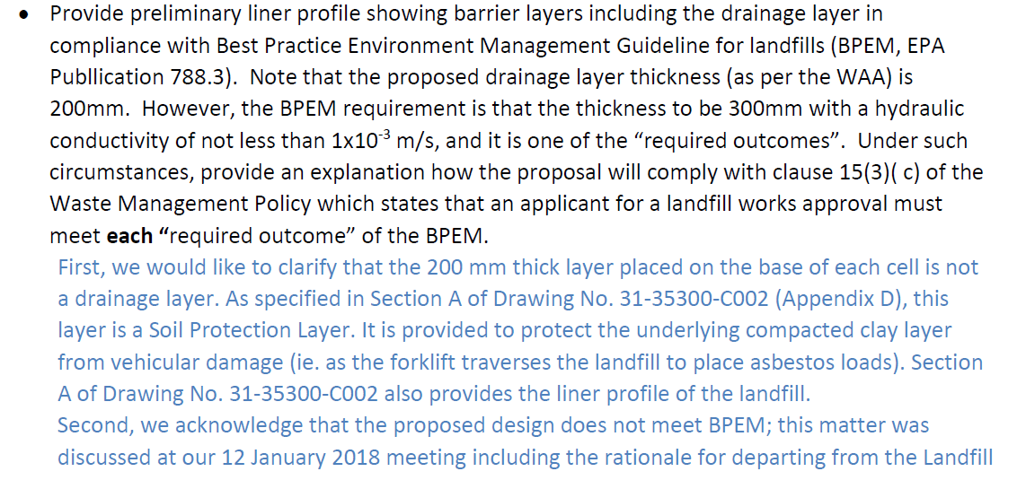
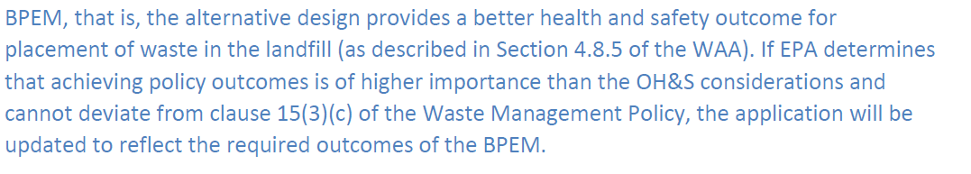

The response is inadequate and not acceptable. See below:

In assessing works approval applications, EPA requires determining whether the application complies with the applicable legislative requirements (policies, regulations, guidelines etc.). It does not attempt to consider one policy vs another in terms of importance. Instead, the assessment considers all relevant legislative requirements as they are applicable to the proposal.

In this application, as stated in this item of s.22 notice, EPA has advised the applicant that the proposal should have a 300mm thick drainage layer with hydraulic conductivity of not less than 1x10⁻³m/s to comply with clause 15(3)(c) of the Waste Management Policy (WMP). Note that this is a “mandatory” requirement (i.e. “required outcome”) as per WMP, and it must be complied with.
Even the client’s response ‘acknowledges that the proposed design does not meet BPEM”, and hence, it does not comply with the WMP in this regard.

In relation to OH&S issues, they need to consider what control measures that can be used to address operational requirements (such as using drilling mats, geogrids etc. over the gravel layer or using appropriate equipments to place material etc.).

EPA’s role is to make sure the application meets the regulation administered by EPA.

Under such circumstances, I cannot recommend this proposal for approval until it complies with WMP.

APPENDIX 10 Continued: ASD Assessment of EBAC response to S22 Notice 1
- An assessment on potential risks on receptors.

The response is acceptable.

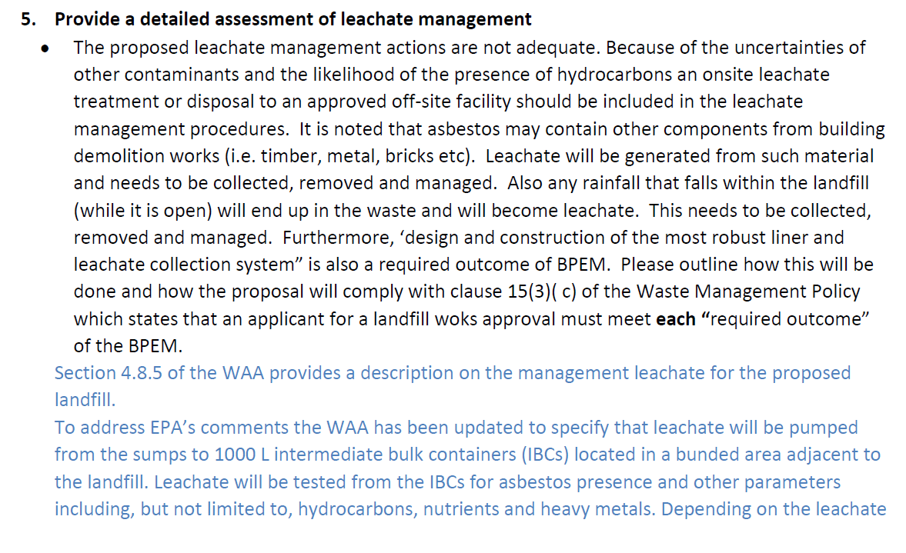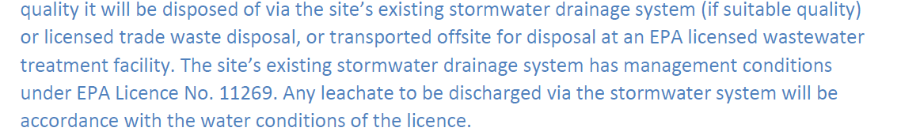

The response is inadequate and not acceptable. See below:

The measures provided in section 4.8.5 of the revised application for minimising leachate generation are acceptable. However, the method of leachate collection is not in line with EPA requirements.

The proposal is a landfill, and for landfills, there should be a 300mm thick drainage layer with hydraulic conductivity of not less than 1x10⁻³m/s to comply with clause 15(3)(c) of the Waste Management Policy (WMP). What is proposed in the application is something different and is well below the requirement. Note that the leachate drainage layer is a “mandatory” requirement (i.e. “required outcome”) as per WMP, and it must be complied with.

Under such circumstances, I cannot recommend this proposal for approval until it complies with WMP.

Furthermore, the application proposes the discharge of leachate into stormwater. Note that leachate is a type of waste, and discharge of waste into stormwater is not allowed. Appropriate discharge mechanism needs to be proposed.

APPENDIX 10 Continued: ASD Assessment of EBAC response to S22 Notice 1
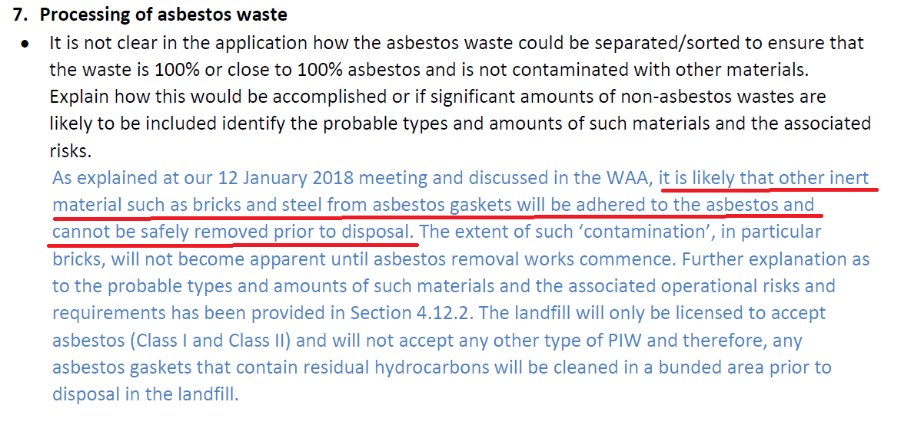

The above response is not sufficient. See below.

The response states that “It is likely that other inert material such as bricks and steel from asbestos gaskets will be adhered to the asbestos and cannot be safety removed prior to disposal”. It is acknowledged that some other contaminants will be in the disposed waste, and therefore, it further stresses the need to address these matters in the application.
To address this, an appropriate leachate drainage layer needs to be incorporated in the design and an appropriate leachate management measure needs to be proposed.

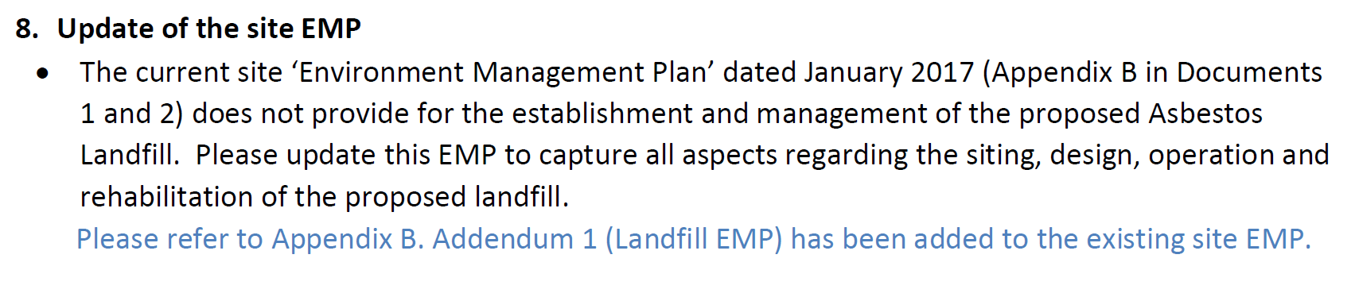
No further comments

APPENDIX 11: ASD Assessment - Further clarification of ASD assessment of EBAC response to S22 Notice 1
APPLIED SCIENCE ASSESSMENT – ADVICE

UPDATED – May 2018:

Further clarification is provided as to why ASD consider this design as not meeting the requirements for a type 3 landfill accepting solid/inert waste material, and the subsequent (potential) environmental risk.

CAVEAT:

This updated assessment takes an objective approach, and is based on the information provided within the report entitled “Energy Brix Australia. Morwell Power Station Asbestos Landfill Works Approval Application” dated January 2018, and the above comment correspondence between GHD/EPA. It is noted that current ASD assessor was not privy to any prior discussions (i.e. the January 12th meeting as noted abo) and potential outcomes and/or agreements (if any). If there are documentation and/or meeting meetings endorsed by all parties involved in previous discussions that may influence and/or contradict the following advice, I would be happy to review, consider and update advice accordingly.

ADVICE:

It is important to note that the drainage layer is a critical component of a landfill barrier system. Details provided in EPA Publication 788.3 (EPA Victoria, 2015) and EPA Publication 1323.3 (EPA Victoria, 2016) describe the requirements and outcomes of BPEM, with some limited context for justification. Therefore, the following information provides a basis for BPEM requirements.

A drainage layer is a critical component of the landfill liner system, which includes the barrier system, leachate collection system (which includes all piping and the drainage layer) and associated geotextile layers. The leachate system is required to remain functional for several decades, which is important for the integrity of the CCL and subsequent protection of the environment.

Consideration was given to section 4.12.2 – waste minimisation, acceptance, pre-treatment and placement (Energy Brix Australia. Morwell Power Station Asbestos Landfill Works Approval Application, January 2018). We note the prescribed steps to minimise environmental impacts through containment by using sealed 44 gallon drums (Class A) or double wrapped plastic (Class B) prior to landfill deposition. Potential risks to the environment are considered low in the short term, but there is concern for long-term as these plastic materials degrade, more specifically for those Class B materials where there is a higher leachate risk potential due to co-occurring materials (i.e. steel, gaskets and refractories). Although it is not clear from the document whether the 44 gallon drums used will be plastic or metal.

The designer acknowledges that the design deviates from current best practice, and ASD note this. However, there are no data supporting how such deviations will meet the objectives for the protection of the environment. As per EPA publication 788.3 (EP Victoria, 2015), where the designer believes that alternative measures can achieve the objectives and required outcomes, these should be supported by a risk assessment. No such assessment has been provided within the report for EPA consideration. In the absence of supporting documentation and/or site specific data demonstrating how the current design deviations will meet the objectives for environmental protection, ASD have no choice but to follow a precautionary approach when assessing the design (i.e. within the BPEM framework), as opposed to a risk based approach.

APPENDIX 11 Continued: ASD Assessment - Further clarification of ASD assessment of EBAC response to S22 Notice 1

Therefore, ASD offer the following advice:

- The use of filter strip drainage is not recommended in landfill design. There is an added risk to leachate system failure as the material does not support on-going maintenance through both video inspection and cleaning. Furthermore, ASD note that drainage strips are generally wrapped in geotextile, which would result in a higher risk of premature failure of the leachate system due to clogging.

- The basis for the aggregate layer requirement (i.e. 0.30m thickness), as stated in EPA Publication 788.3 (EPA Victoria, 2015), is to ensure the integrity of landfill liner system. It is well understood that, over several decades, leachate collection systems will fail. This design requirement is important to ensure the landfill liner system is still able to remove liquid from the CCL surface through natural drainage alone in the event of system failure of the piping material. Without adequate drainage, there is potential for the development leachate head in areas of the CCL, which could result in the leakage of contaminants to the environment either through advective flow, or in extreme cases liner failure.

APPENDIX 12: EBAC response to S22 Notice 2
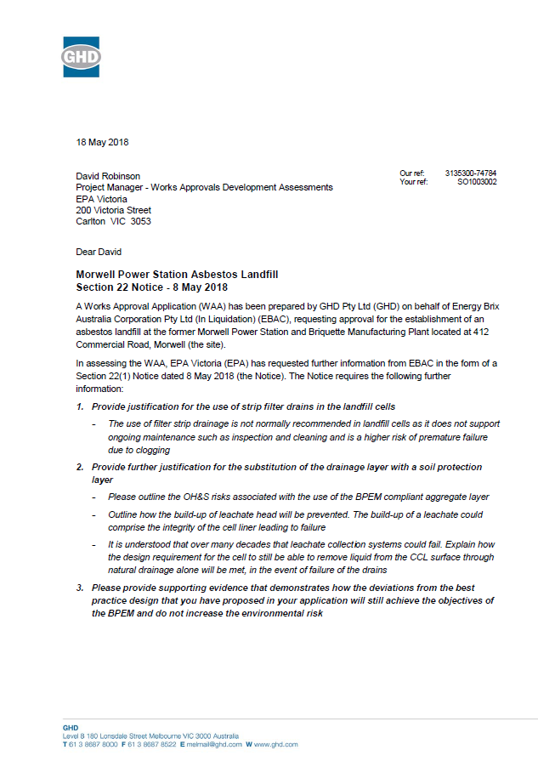

APPENDIX 12 Continued: EBAC response to S22 Notice 2
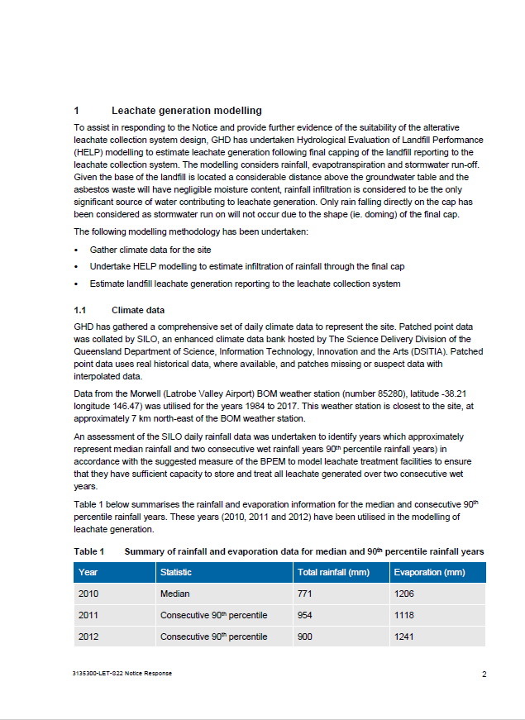

APPENDIX 12 Continued: EBAC response to S22 Notice 2
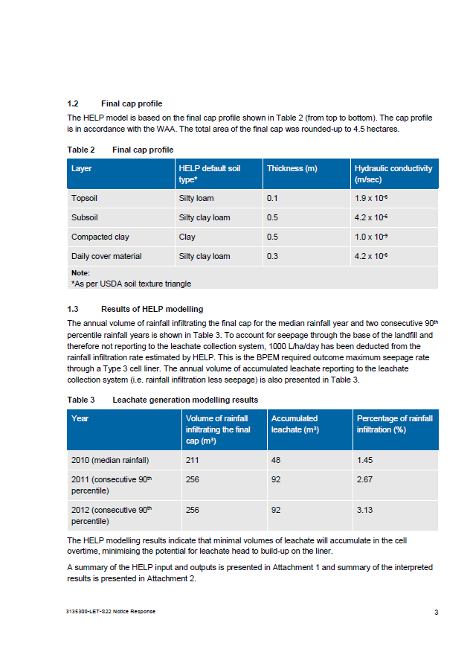

APPENDIX 12 Continued: EBAC response to S22 Notice 2
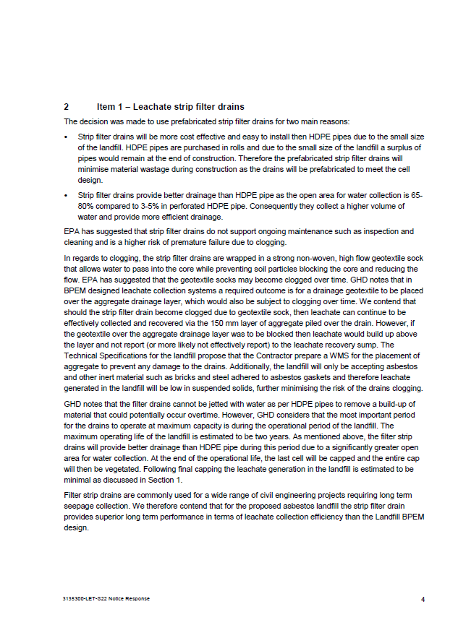

APPENDIX 12 Continued: EBAC response to S22 Notice 2
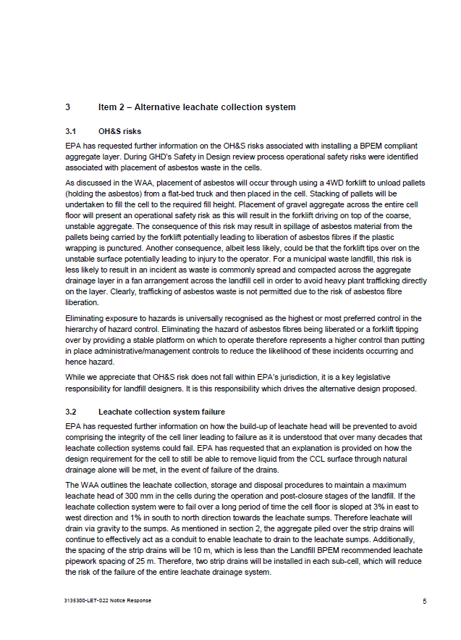

APPENDIX 12 Continued: EBAC response to S22 Notice 2
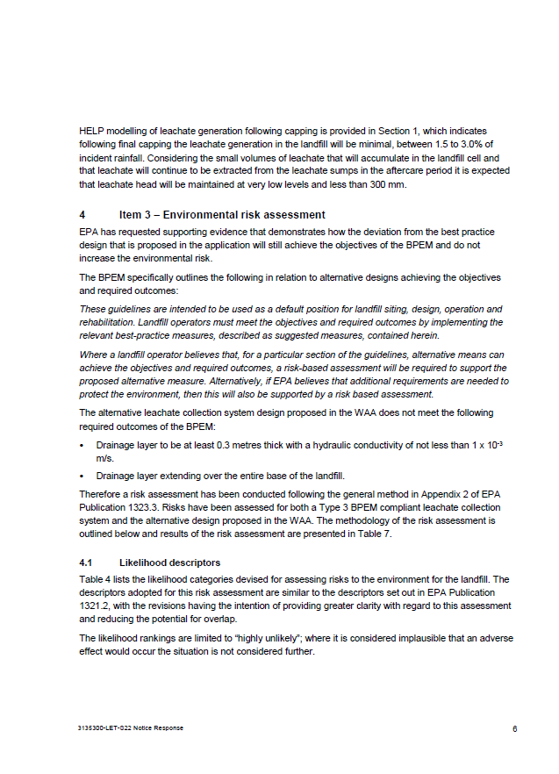

APPENDIX 12 Continued: EBAC response to S22 Notice 2
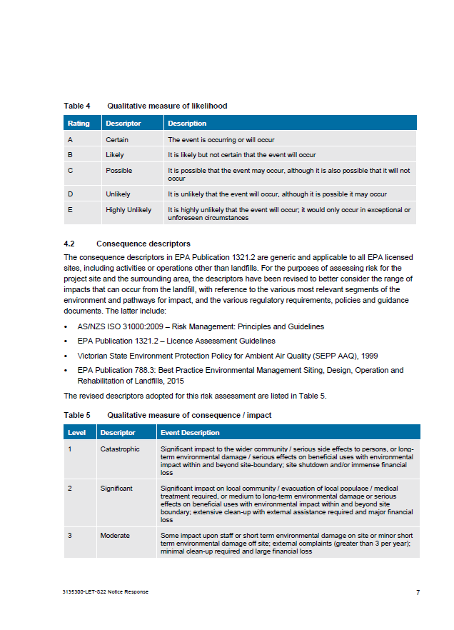

APPENDIX 12 Continued: EBAC response to S22 Notice 2
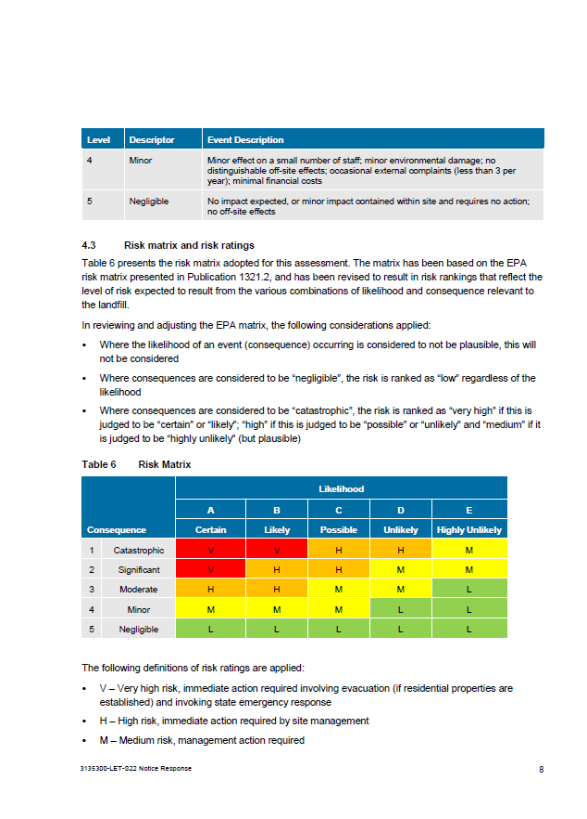

APPENDIX 12 Continued: EBAC response to S22 Notice 2
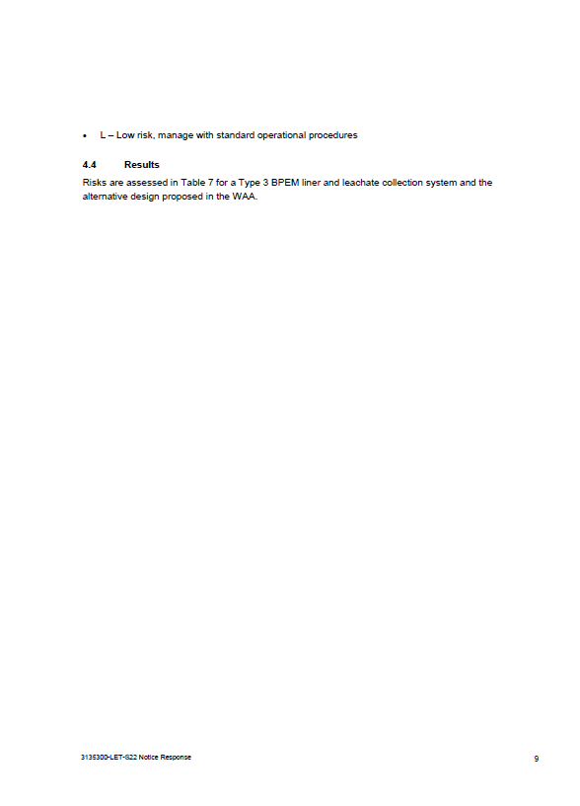

APPENDIX 12 Continued: EBAC response to S22 Notice 2
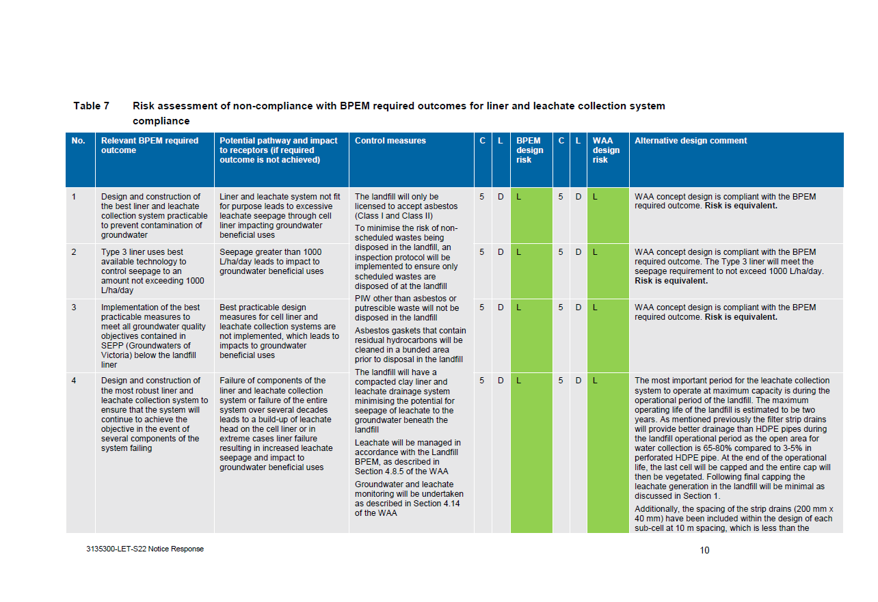
APPENDIX 12 Continued: EBAC response to S22 Notice 2
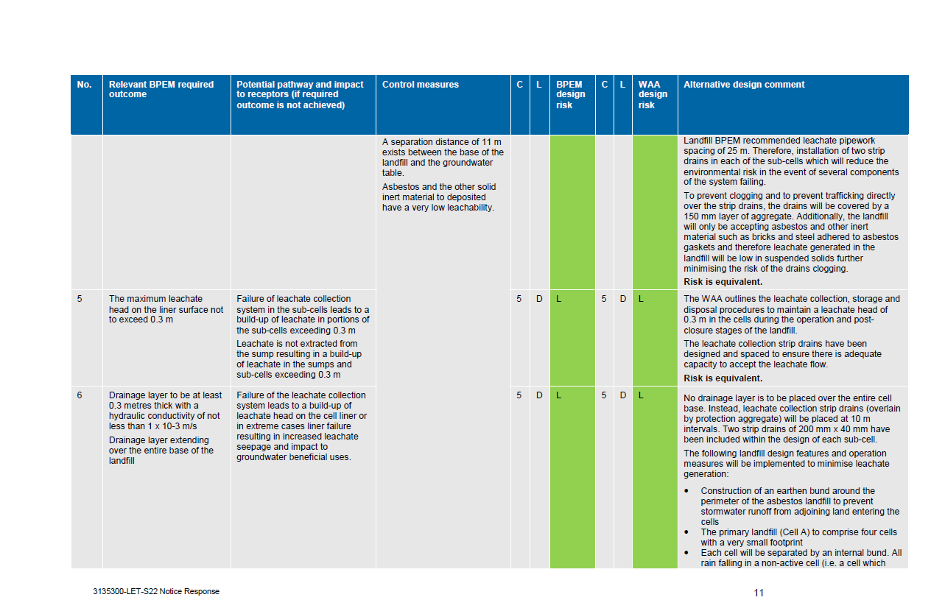
APPENDIX 12 Continued: EBAC response to S22 Notice 2
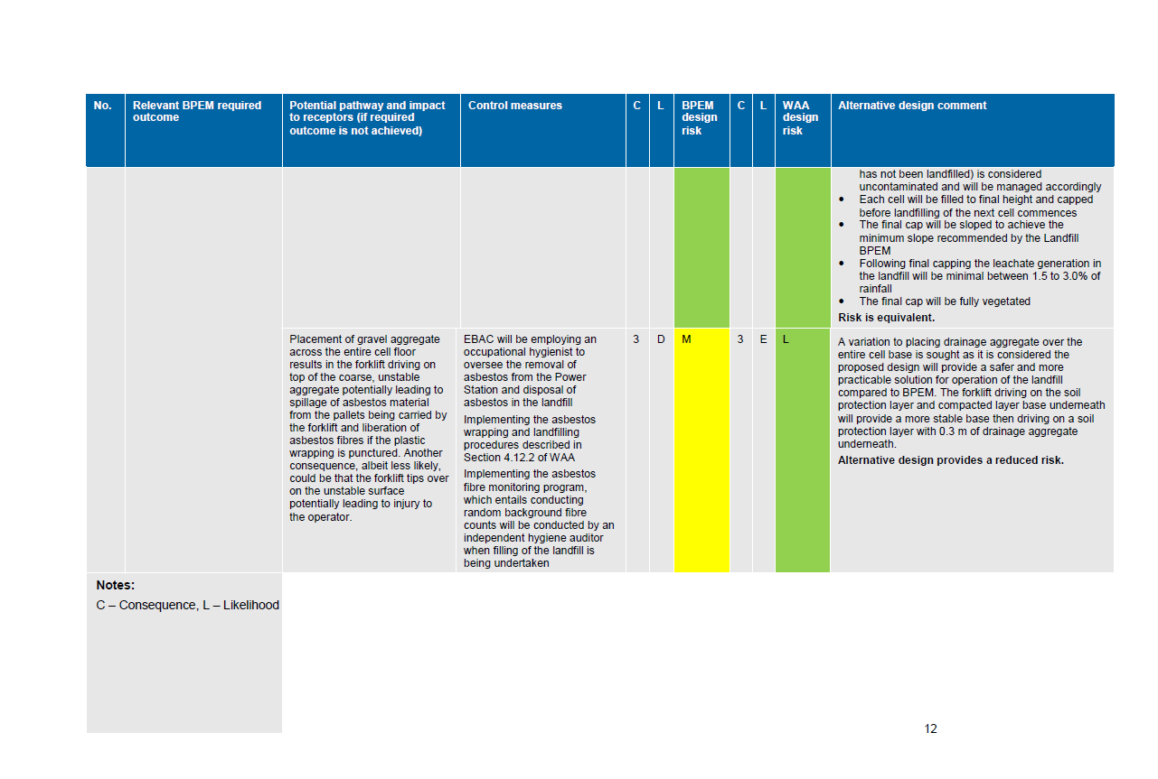

APPENDIX 12 Continued: EBAC response to S22 Notice 2
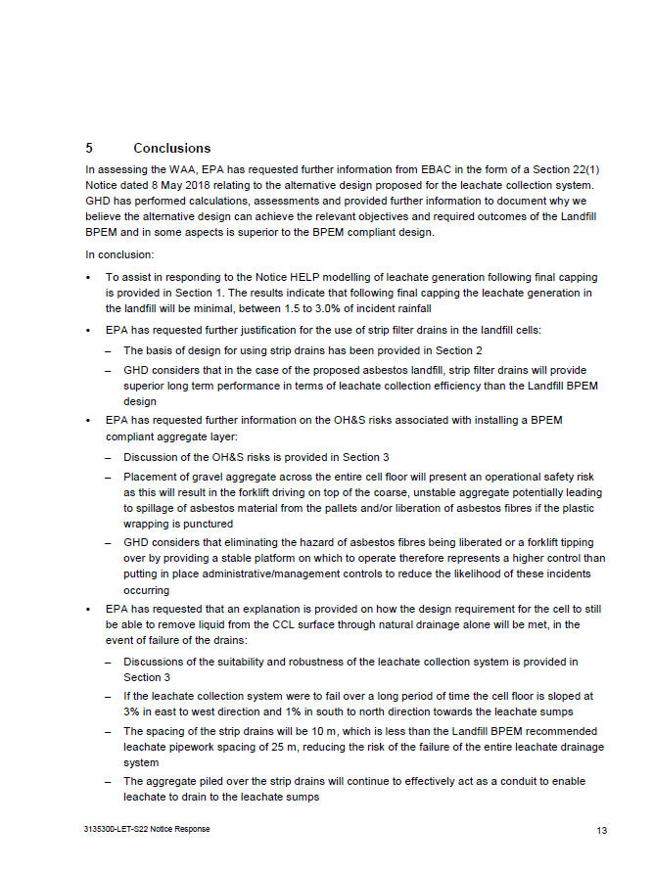

APPENDIX 12 Continued: EBAC response to S22 Notice 2
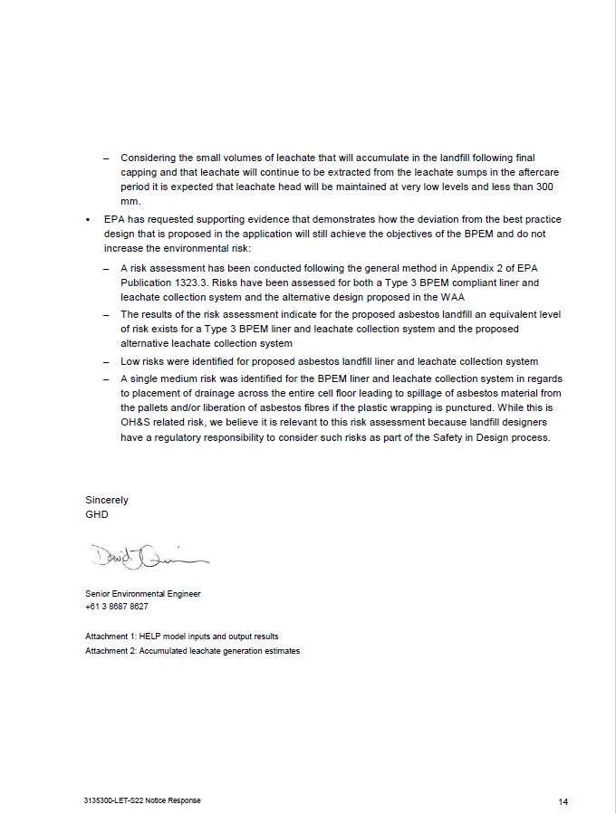

APPENDIX 13: ASD Assessment of EBAC response to S22 Notice 2

- APPLIED SCIENCE – ADMINISTRATIVE INFO
EXPERT(S) | Michael Clough
INITIAL CALL TO DAU DATE
QUALITY OF DAU REQUEST | Please start a new row in this spreadsheet
CLOSING CALL TO DAU DATE
- APPLIED SCIENCE ASSESSMENT – ADVICE AND SUMMARY
DOCUMENTS REFERENCED
Section 22(1) Notice sent 8 May 2018 “Re: Works approval application SO 1003002 from Energy Brix Australia Corporation Pty Ltd to establish an asbestos landfill at 412 Commercial Road, Morwell.

Section 22(1) Technical response letter dated 18 May 2018 (GHD Reference Number 3135300-74784);

The report titled “Energy Brix Australia, Former Morwell Power Station, Phase 2 Environmental Site Assessment”, dated March 2018 prepared by GHD.

SUMMARY
Further clarification was provided by ASD as to why it considered the design submitted by GHD did not meet the objectives of publication 788.3 (EPA Victoria, 2015) for a type 3 landfill accepting solid/inert waste material, and the subsequent (potential) environmental risk. This information is filed under IAR 545160 - ASD response.

Concerns were raised in previous ASD responses and/or communication about uncertainties regarding leachate generation by the material that will be comingled with the asbestos containing material (ACM). This included materials with unknown leachability characteristics (i.e. timber, metal, refractory material (bricks)). In the absence of supporting data (such as a comprehensive HAZMAT survey with leachability analysis) and/or other supporting information (i.e. expected leachate volume generation) ASD could not quantify the deviation of the design in relation to BPEM, specifically as it related to the drainage layer/leachate collection system and all associated components. As such, ASD recommended to DAU that the design must meet BPEM requirements in the absence of supporting data. These concerns were also relayed to the duty holder representatives during a face-to-face meeting on May 11th. Attention was drawn to section 6 – Best Practice Design (Publication 788.3, EPA Victoria, 2015) “Where the landfill designer believes that alternative measures can achieve the objectives and required outcomes, these should be supported by a risk assessment”.

APPENDIX 13 Continued: ASD Assessment of EBAC response to S22 Notice 2

EPA issued a request for further information in the form of a Section 22 Notice, dated 8 May 2018, seeking clarification on Technical aspects of the application, specifically the following:

- Provide justification for the use of strip filter drains in the landfill cells:
- The use of filter strip drains in not recommended in landfill cells as it does not support on-going maintenance such as inspection and cleaning and has a higher risk of premature failure due to clogging;

- Provide further justification for the substitution of the drainage layer with a soil protection layer:
- Please outline the OH&S risks associated with the use of the BPEM compliant aggregate layer.
- Outline how the build-up of leachate head will be prevented. The build-up of a head of leachate could compromise the integrity of the cell liner leading to failure.
- It is understood that over many decades the leachate collection systems could fail. Explain how the design requirement for the cell still be able to remove liquid from the CCL surface through natural drainage alone will be met, in the event of failure of the drains.

- Please provide supporting evidence that demonstrates how the deviations from the best practice design that you have proposed in your application will still achieve the objectives of the BPEM and do not increase the environmental risk.

A response to the Section 22(1) notice was submitted by GHD dated 18 May 2018 and forms part of the current review and subsequent ASD advice.

ADVICE

ASD note the following assumption that has been considered when formulating our advice (as stated in the report titled “Energy Brix Australia, Former Morwell Power Station, Phase 2 Environmental Site Assessment”, dated March 2018 prepared by GHD):

- “The landfill will only be receiving solid inert asbestos waste. All other waste material [generated during demolition] … will be… either recycled or disposed at appropriately licenced landfill site”.

Therefore, ASD assume ALL waste entering the proposed landfill will be handled in accordance with publication 611.2 (EPA Victoria, June 2017), and as described in section 4.12.2 of the GHD report
APPENDIX 13 Continued: ASD Assessment of EBAC response to S22 Notice 2

(March 2018), as being contained in either double wrapped polythene plastic or contained in 44 gallon drums.

A risk minimisation strategy, specific to this assumption, is identified in Table 7 of the response dated 18 May 2018. Please see section below “Comment on Risk”.

- Provide justification for the use of strip filter drains in the landfill cells

ASD recognize the increased performance provided by the proposed filter strip drainage in terms of drainage capacity, generally 10-15 times more efficient than material proposed in BPEM. We also consider the additional measures identified in section 4.8.4, 4.8.5 and 4.8.6 regarding leachate management and stormwater management, which would also limit the amount of leachate generated during landfilling activities. Based on this information, and the results of the HELP model, this deviation would be considered low risk and acceptable.

- Provide further justification for the substitution of the drainage layer with a soil protection layer.

- Please provide supporting evidence that demonstrates how the deviations from the best practice design that you have proposed in your application will still achieve the objectives of the BPEM and do not increase the environmental risk

The supporting evidence (HELP modelling) provided suggests infiltration rates be 40% below the recommended seepage rates as stated in BPEM, therefore it is considered to further reduce the environmental risk due to future leachate generation.

Other supporting evidence includes additional management practices proposed under sections 1.1 and 4.12 of the March 2018 report – the operating life of the landfill will be two years, with four cells to be progressively filled and capped prior to commencing filling of future cells over this period.

Leachate Generation.

It is noted the potential for leachate to generate hazardous dissolved or suspended solids during both landfilling activities, and post rehabilitation, is considered low based on the following lines of evidence provided:

During Landfilling activities: The material entering the proposed landfill will be handled in accordance with publication 611.2 (EPA Victoria, June 2017), and as described in section 4.12.2 of the GHD report (March 2018). These materials will either be double wrapped in polythene plastic or
APPENDIX 13 Continued: ASD Assessment of EBAC response to S22 Notice 2
contained in 44 gallon drums, therefore eliminating the leachability pathway of the waste in the short term. Careful placement in the landfill will be critical to ensure that the polythene plastic is not ripped or drums damaged during deposition.

Post Capping: Even if/when degradation of the plastic material and drums containing ACM and (possible) co-mingled materials occurs. Potential for leachate generation is considered low due to evidence provided in the HELP model.

Other concerns identified previously by ASD were related to longevity of the leachate system collection, and the ability to function satisfactorily in the event of component failure (i.e. drainage pipe failure) after rehabilitation. Based on HELP modelling, ASD consider the risk of drainage failure to be low.

ASD consider the risk assessment contained in the 18 May 2018 satisfactorily addresses all the concerns previously raised by ASD, and the risk to the environment due to these deviations would be considered low.

COMMENT ON RISK

Risk has been assessed for both design and modelling. As per any risk assessment, where controls have been identified to reduce risk (both engineering and administrative), it is important that these are implemented, verified (both independently and by duty holder) during the implementation phase and maintained through the operational life and post-closure.

APPENDIX 13 Continued: ASD Assessment of EBAC response to S22 Notice 2

- APPLIED SCIENCE ASSESSMENT - PEER REVIEW
PEER REVIEW REQUIRED/RECOMMENDED  (use decision matrix in SOP) | ☐Yes  If yes, level recommended:  ☐high  ☒medium  ☐low | ☐No  If no, why not:  ☐standard advice  ☐low risk/low complexity  ☐not available  ☐other:
PEER REVIEW REQUEST:  SCOPE AND TYPES | Scope:  Sense check on thought process in RA | Types:  ☒technical  ☒language and style  ☐science communications  ☒strategic alignment
PEER REVIEWER(S) | Laura-lee Innes
PEER REVIEW DETAILS | <what was/wasn’t included in scope>

- DAU CLOSE OUT FRAME
QUALITY OF APPLIED SCIENCE FEEDBACK | Please find your request in this spreadsheet, and complete it.

Version | Date | Author | Summary of changes
0 | Creation date | David Robinson | Creation of form
1 | 23/05/2018 | Michael Clough | Filled in AS parts
2 | 24/05/2018 | Laura-lee Innes | AS peer review

APPENDIX 14: Contour Plans
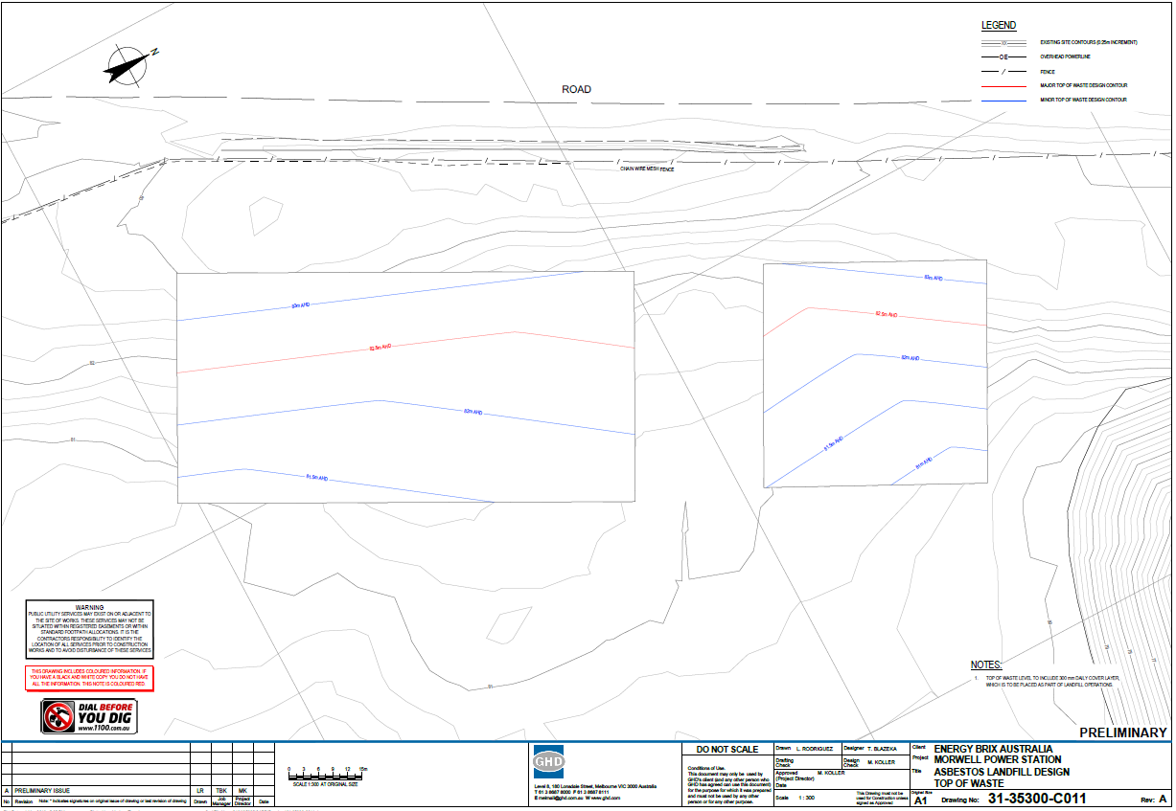
APPENDIX 14 Continued: Contour Plans
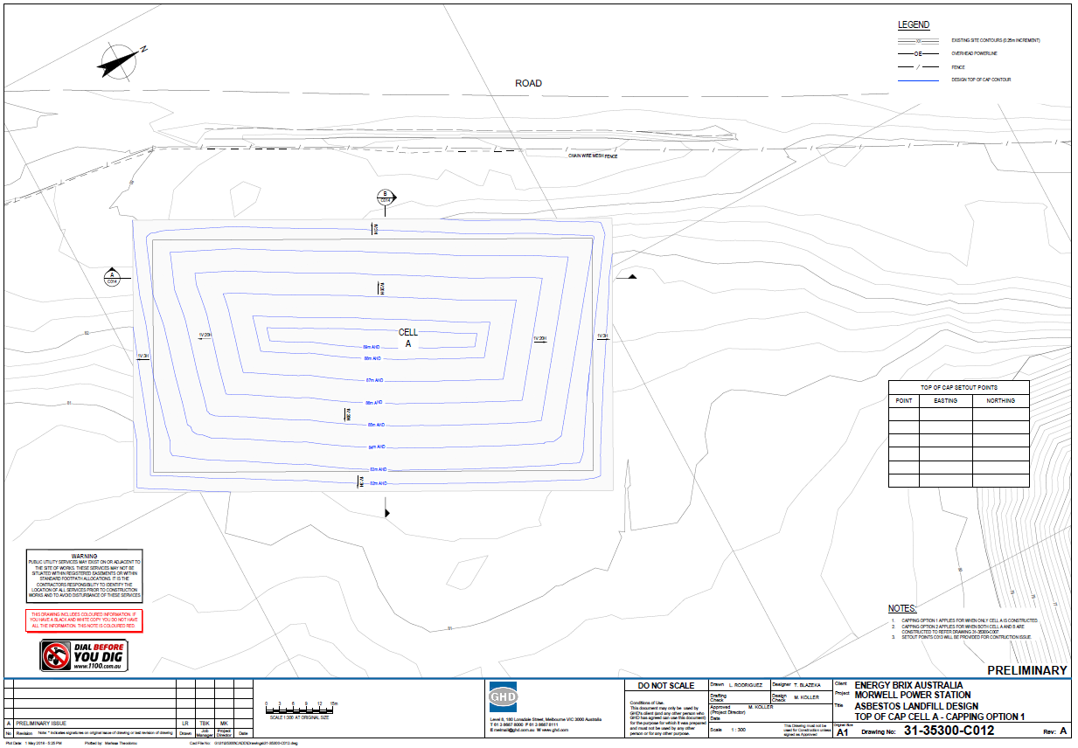
APPENDIX 14 Continued: Contour Plans
